Isaac Basque-Rice

12basque-rice.i@thestudio-liverpool.net

Requirements Specification Document

A requirements specification for my Fasthosts website

Contents

Requirements Specification – Isaac Basque-Rice 1

1.0 Introduction 2

1.1 Scope 3

1.2 Timeframe 4

1.3 Definitions, acronyms, abbreviations 4

2.0 Design 5

2.1 Visual Style 6

2.2 Visual Layout 7

2.3 Database Design 11

3.0 Development 15

3.1 Pages 16

3.2 Master page 16

3.3 Homepage 26

3.4 Search Page 32

3.5 Registration Page 34

3.6 Login Page 38

3.7 Contact Form 40

3.8 Misc. Backend 43

4.0 Additional Requirements 44

Themes and usability 45

Accessibility 48

4.1 Cross-Browser Differences 49

References 52

# Introduction

I have been asked, by Fasthosts ltd., as a junior developer, to build and deploy a website that allows **user**s to register interest in and view the releases of various Top-Level Domains, or **TLD**s. It will also have the ability to notify users when the TLD they registered interest in has become available and also store data about users (fore/surname, email) and of course their vested interests in TLDs.

Due to the scope of this project (discussed further in section 1.1), I have been asked to make use of the process of documentation in order to plan out an efficient and (hopefully) elegant solution to the task I have been set. As such, the remainder of this document will be a description of the intended design of and solution to said task. In addition to the broad descriptions within this document you will find in depth description of the development process, obstacles within said process, how those obstacles were overcome, and, of course, evidence for all of these (e.g. screenshots) will be supplied in line with the content it is referencing.

## Scope

The scope of this project is, in a word, immense (relative to other, much smaller projects I have undertaken) and as such will follow three separate phases:

* Front End Development

This is the section of the website that the user will view. An accurate analogy for this would be the stage within a theatre; this will encompass, primarily, a homepage for the TLD registry, a login/sign up page, a search function for searching for and registering interest in various TLDs, and a page which displays the TLDs the user is interested in and allows them to edit and/or delete them.

The logon/sign up page will serve as the ‘face’ of the data collection system in my solution, it will allow the user to input their forename, surname, username, email address, and a password of their choosing.

The front end will be created in Microsoft’s Visual Studio software using **HTML**, **CSS**, and the **ASP.net** framework

* Back End Development

Continuing the analogy to a theatre, this section represents backstage, all the technology that the user doesn’t necessarily see but is necessary for the function of the solution. In our case the most vital form of back-end technology will be the relational database system.

There will be three tables in the database, one for the user’s details (User ID, which will be the **primary key**, as well as both names, email, username, password, and TLD interest in no particular order, however nulls are allowed under TLD interest in the sign-up page), one for the TLDs the User has registered interest in (TLD ID which will be the primary key, alongside the TLD name and TLD price) and finally Interest, which will include Interest ID and the other two IDs from the two tables. These three tables will be linked ‘relationally’, meaning certain pieces of data in one table will be linked with another, and be managed by Microsoft’s **SQL** Management Server **RDBMS**

In addition to databases, backend development also encompasses the communication/interface methods between the solution and the databases, as well as **validation** methods.

* Stylings

The majority of the stylings (or look) of the project must be left until after the functionality of the website is 100% assured, basic stylings can and must be applied throughout the process in order for the website to be testable and for me to understand basic issues with styling and content better than I otherwise would have.

Fasthosts have asked me to stick to a basic colour scheme, a series of blues and white, which I will adhere to and detail much more in section 2.1 - Visual style.

## Timeframe

The deadline for this project is the 31st of January, 2018, as such I have 68 days in total to complete the assignment, or 9 weeks and 5 days, I shall allocate 2-3 weeks for planning and design and the subsequent 5 weeks being implementation of said design, amongst other aspects of development such as troubleshooting etc.

## 1.3 Definitions, acronyms, abbreviations

|  |  |
| --- | --- |
| Word | Definition |
| TLD | Top Level Domain – the last segment of a domain name (.com, .org, .net, .co.uk, are all examples of TLDs) |
| User | The individual who uses the website |
| HTML | HyperText Mark-up Language, the scripting language responsible for content creation and management on any given website, currently on version 5 |
| CSS | Cascading Style Sheets, the scripting language that allows for the application of styles to content, managing the appearance, colour, position (amongst many others), of various HTML elements |
| ASP.net | Active Server Pages, a **server-side** application framework designed to produce dynamic web pages, provides an **API** for web developers |
| API | Application Programming Interface, a set of commands, functions, protocols, and objects programmers can use to create software or websites or interact with external systems, provides standard commands so developers do not have to code from scratch |
| Server-Side | On the server (central computer responsible for holding data, amongst others) side of a server-client relationship |
| SQL | Structured Query Language (Pronounced Sequel) is the language I’m using to communicate with the database |
| Primary Key | The field in a table which uniquely identifies each row/record in a database table |
| RDBMS | Relational Database Management System, the software used to manage databases, in this instance I will be using Microsoft SQL server, however there are many others such as Oracle Database, MySQL, and Microsoft Access |
| Validation | Validation, in a web development context, is the process of checking for correct data input, for example, a web developer may need a user to input an email address, for this, in the server side language, the developer must input the validation expression \w+([-+.']\w+)*@\w+([-.]\w+)*\.\w+([-.]\w+)*, which checks for the presence of an @ symbol |
| Header | At the top of a website, usually displays some kind of logo/brand information as well as links and other information |
| Footer | At the bottom of a website, usually contains legal and authorship information as well as social media links and further links to other parts of a website or information about the website |
| Nav bar | An unordered list consisting of links usually (but not always) found in the header of a website, allows for navigation within the website |
| Hex | Hexadecimal, a base 16 counting system using the values 0-9 and A-F, in the context of colours the RGB values of every individual colour is encoded into Hexadecimal, for example, the colour Indigo (RGB 75, 0, 130) would be encoded as #4B0082, 4B=75, 00=00, 82=130 |
| RGB | Red, Green, Blue, the amount/ intensity of Red, Green, and Blue light in each pixel on screen |
| Master Page | A master page is a page within a website solution that applies itself to all other pages within that solution, used for headers, footers, and websites that display different content in the same format such as Amazon or YouTube |
| Int | Integer, a data type found on SQL databases that mean only numbers are allowed within the column |
| Nvarchar | **Unicode** Variable-length Character string, a data type found in SQL databases that mean any and all Unicode characters are allowed within the column |
| Unicode | A character encoding standard that includes every single character one could possibly need, including the Latin, Greek, Arabic, Japanese, Chinese, Korean, and Cyrillic alphabets, as well as Emoji and other special characters |
| Null | A null, in the context of a database, is a section in the database that has no information in it whatsoever |
| WYSIWYG | What You See Is What You Get, another description for a visual editor, all information you see on screen is in approximately/totally the same form you would see when the solution is put into effect (see: the Visual Editing section of Visual Studio) |
| Lorem Ipsum | A collection of random, nonsense Latin words that are designed to serve as a content placeholder to demonstrate different text-based capabilities, such as font size, font family, colour etc. |
| Inline | HTML or CSS that exists not in its own separate document that is linked within the header, but instead exists solely within the header, usually considered bad practice. |

# Design

The design of this website must approximately adhere to the style and layout of the Fasthosts website (fig. 1, 2), that is, a **nav bar**, **header** and **footer**, the use of the logo, and the use of the several colours of blue as described in section 2.1, in addition to this the content of the website must be befitting of a standard TLD registry page, for example perhaps a portion of the home page may be dedicated to defining a TLD, or an ‘about us’ section.



Figure 1

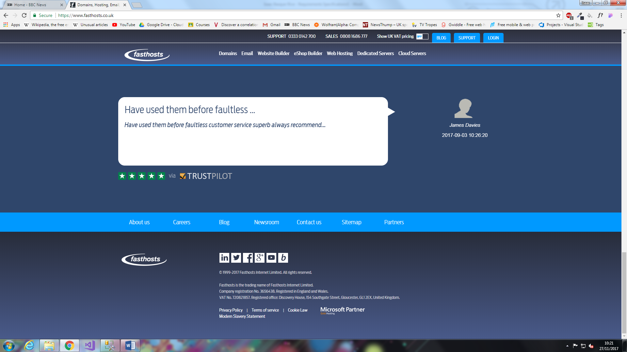

Figure 2

## Visual Style

|  |  |  |
| --- | --- | --- |
| Colour | Hex code | Description of use |
|  | #3A4058 | 1st of 2 Primary colours, used for the header and the footer of the website |
|  | #0099FF | Secondary colour, primarily used for buttons and sectional dividers |
|  | #55BBFF | Secondary colour, on hovering over the links. |
|  | #495989 | 2nd primary colour, used for the navigation bar |
|  | #FFFFFF | Background colour |

Arguably, the most important aspect of being commissioned to design a website for an outside entity (as I have been with Fasthosts) is keeping in line with the already pre-existing brand, e.g. logos, colouring etc. As such I have made a table (see above) of relevant colour **hex** values picked from the live Fasthosts website using the ColorZilla extension for Google Chrome and have proceeded to implement them in my mock-up of the stylings and content for my website (see figures 3 and 4).

The reasoning behind my choice of multiple primary colours is that due to the presence of a gradient in the header, footer, and nav bar of the base website, it may be difficult to distinguish between the two, as well as my opinion that solid colours appear cleaner on a website.

In addition to colouring, in order to stay in line with the Fasthosts brand I must also apply the Fasthosts logo to the header and footer of all given web pages.

Figure 3 (below), as mentioned previously, is an approximation of the stylings I will use, the white space being reserved for content. The content within the footer is directly sourced from the Fasthosts website (as shown in figure 2).

Beyond colouring I will be approximately adhering to Google’s material design scheme, that is making use of drop shadows when necessary, and being influenced by print-based materials (such as paper). An example of this in the template below (fig. 3) is that the buttons on the top have been coloured in #0099FF, the colour of the nav bar, in order to give the layered appearance that is so intrinsic in Material Design, being that the header is layered on top of the nav bar which is in turn layered on the backdrop. Drop shadows may be added at a later point.

## Visual Layout

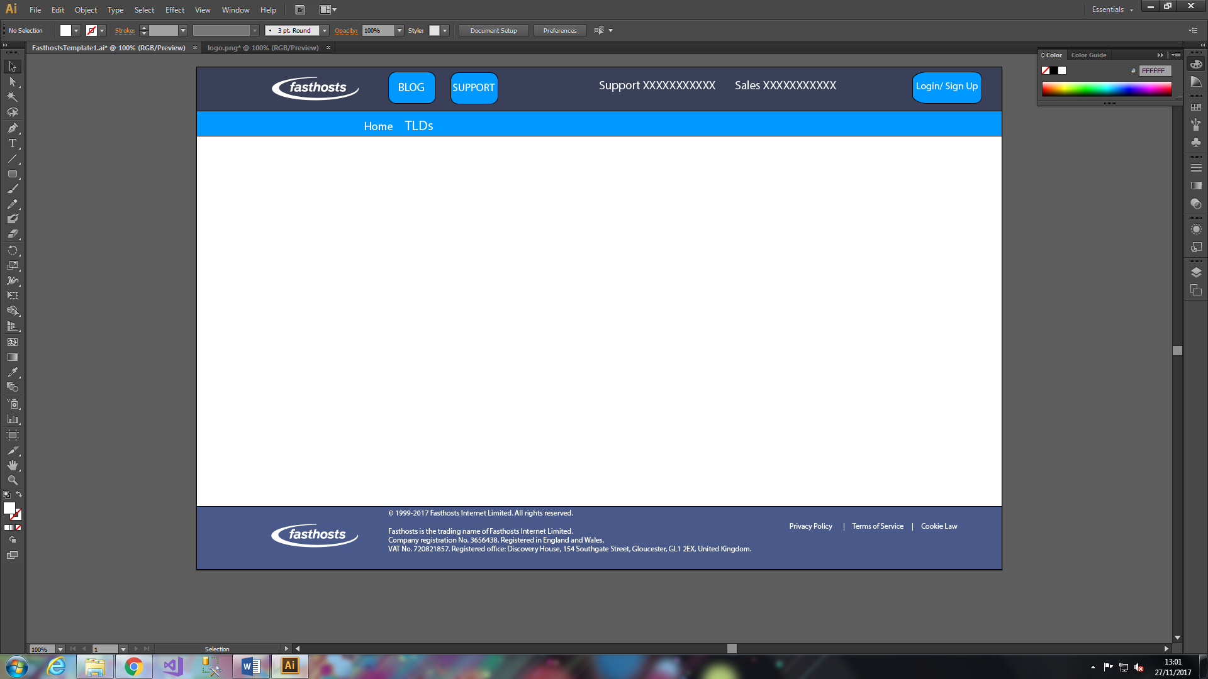 Figure 3

Figure 3 is an *approximate* universal template, designed for application on the **master page** within the website solution in Visual Studio, along the top we have the header, in which we have the all-important logo (the significance of which was mentioned previously) a button designed for linking to the Fasthosts Blog and for linking to Fasthosts Technical Support (as is on the header in the base site), as well as phone numbers (denoted by eleven Xs next to each other) also included on the base site. The login button is designed to link to the login page that I will have built (see below). Moving on to the Nav bar we currently have two links, one to the home page and one to a list of TLDs that users have the ability to register interest in by checking a tick box next to the TLD and then continuing.

In the footer we have legal information taken from the Fasthosts website itself, as well as links to the Privacy Policy, Terms of Service, and Cookie Law as is displayed on the base site. All links that do not link to other parts of the solution (e.g. Blog, Support, privacy policy, terms of service etc.) will link to their corresponding sections on the Fasthosts site itself.

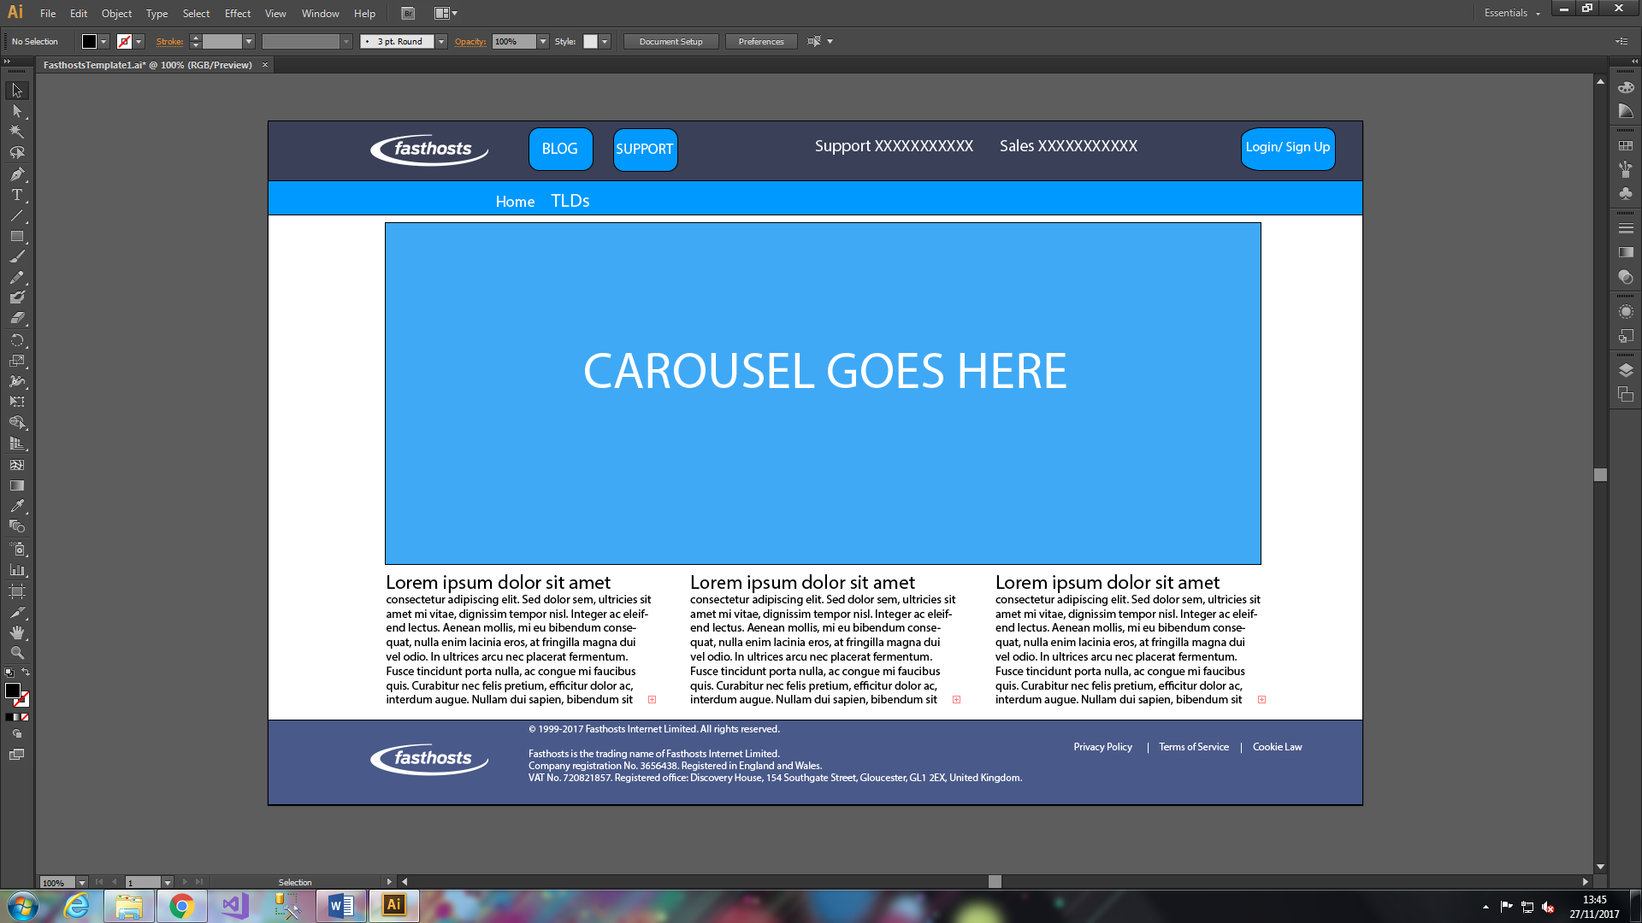

Figure 4

Figure 4 is a mock-up of the view you will see when the page is loaded in, the landing page, a large carousel of images at the top, catching the eye of the user straight away. As such important information must be placed in the carousel. Underneath the carousel is three blocks of text; this, naturally, can be merged into one, and will most likely be used for displaying information such as definitions for the various concepts that are a prerequisite for a TLD registry.

Traditionally, the content of a website is styled to take up 80% of the webpage when viewed on a desktop or laptop computer, meaning 10% empty space on either side of the content, I will be adhering to this standard as it is my belief that it makes the website appear better than edge-to-edge content.

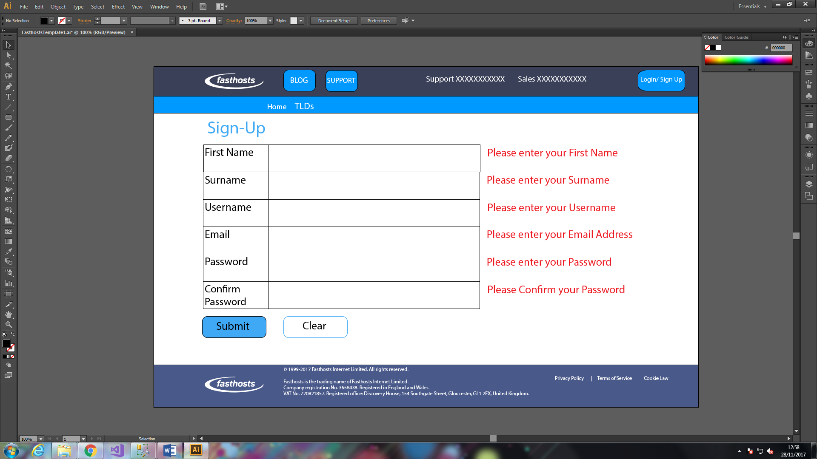

Figure 5

Figure 5 is a mock-up of the registration page I will use in the website, here we will have text input fields next to the relevant boxes, on display here we also have the required field validators, they have noticed the text boxes are empty and as such have notified the user of their need to give input.

It could be argued that this section is where the ASP.net core, on which the whole website is based, comes most into effect, as most if not all onscreen items will be applied using asp.net services. This section will be written by me by using the inbuilt **WYSIWYG** tools in Visual Studio, which will involve drag-and-drop text input fields and buttons, as well as regular expression validators assigned to the text boxes.

In addition to the text fields, below we also have a submit button (in blue) and a clear button (in white with a blue outline) these buttons do what they say, submitting the form to the database and clearing the form of any information, respectively.

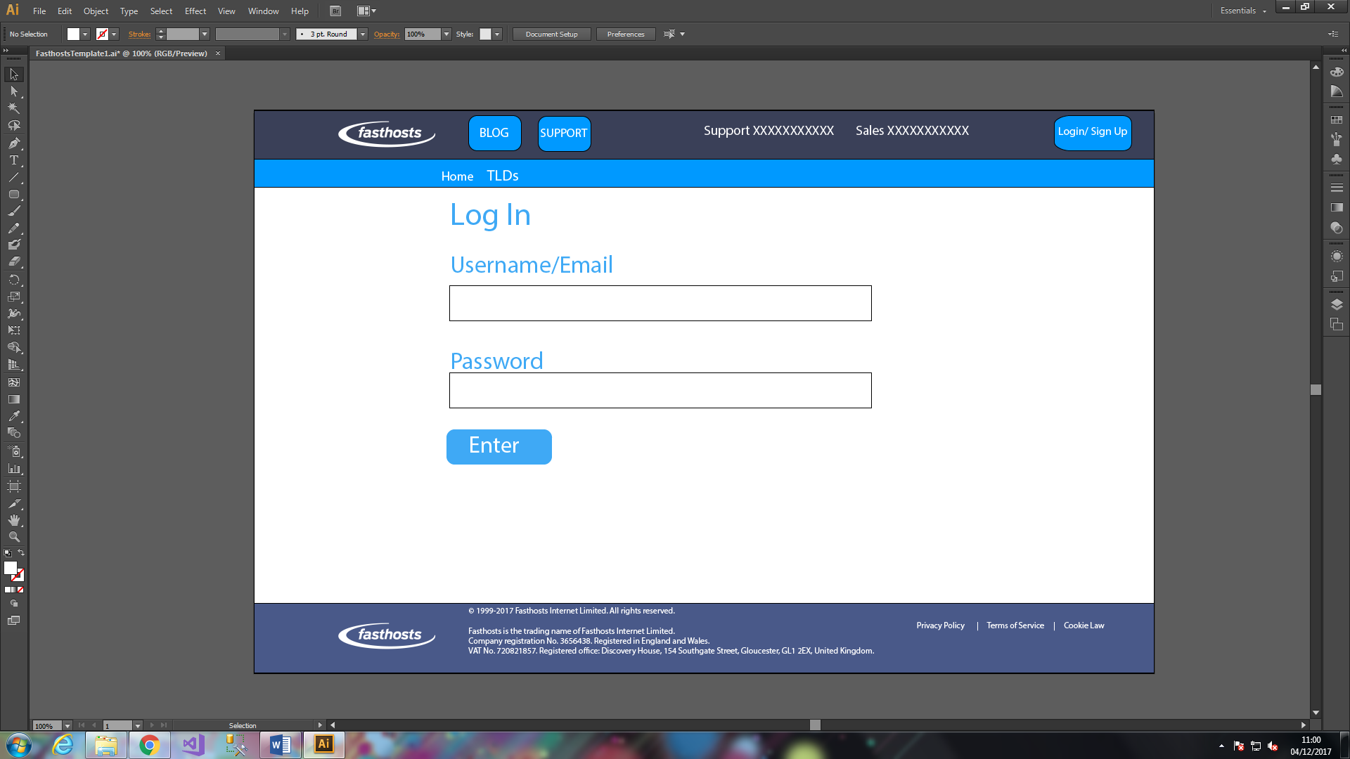

Figure 6

Figure 6 is the login page, it allows a user to enter a combination of either their username or email and their pre-set password. As above, the login page will make use of ASP.net for buttons, text fields, and regular expression validators.

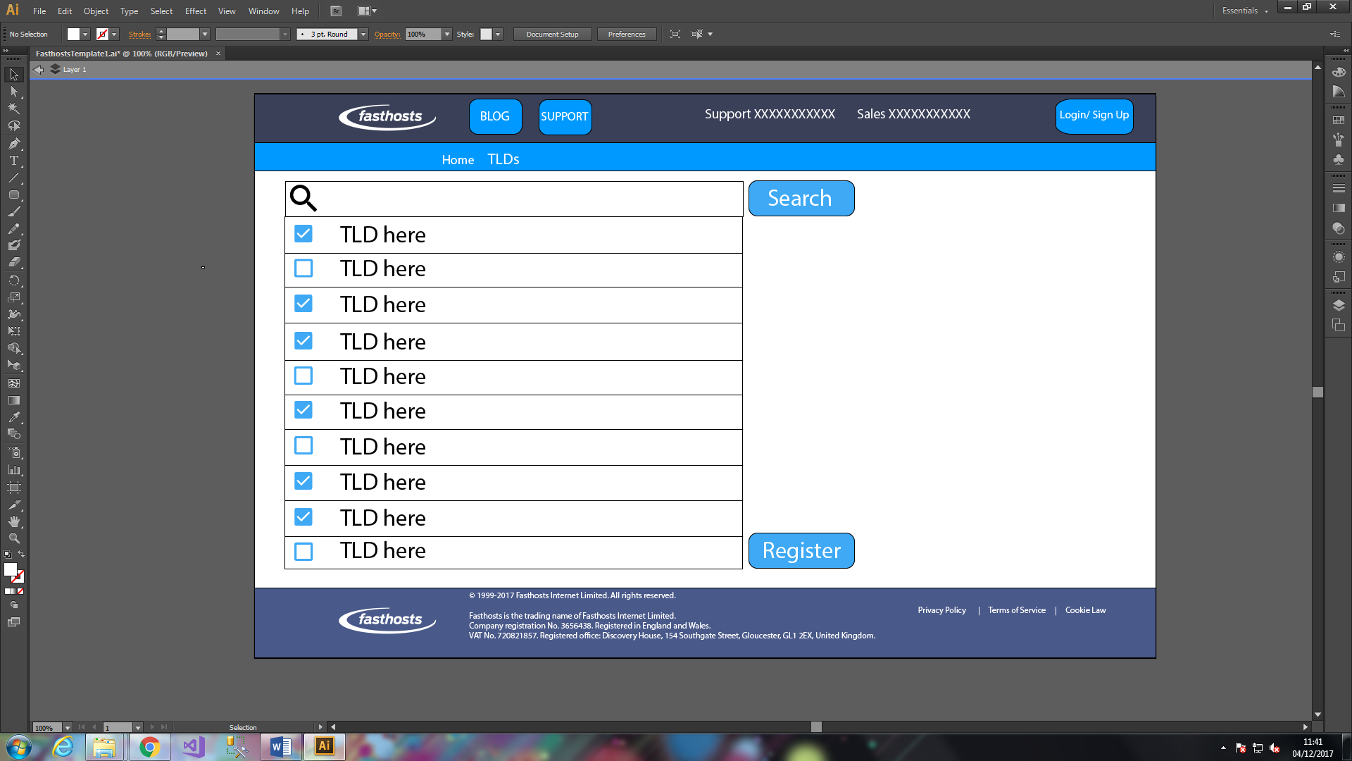

Figure 7

Figure 7 is the TLD interest page, users will register their interest in various TLDs here on two separate occasions, immediately post-registration, and at any other point they wish when clicking the ‘TLDs’ link in the nav bar. The TLDs themselves will be stored in the ‘TLD’ table in the database, as seen in figure 9. Any information pertaining to TLD interests of a specific user will be stored in the ‘Interests’ table in the database, as seen in figure 10.

## Database Design

In this section of the documentation I will describe the design for the most noteworthy aspect of backend development in my solution, the database, tables within it, and the relations between those tables. The database I have laid out for my solution comprises of three separate tables: Users, TLD, and Interest, each of which playing a distinct role in my solution.

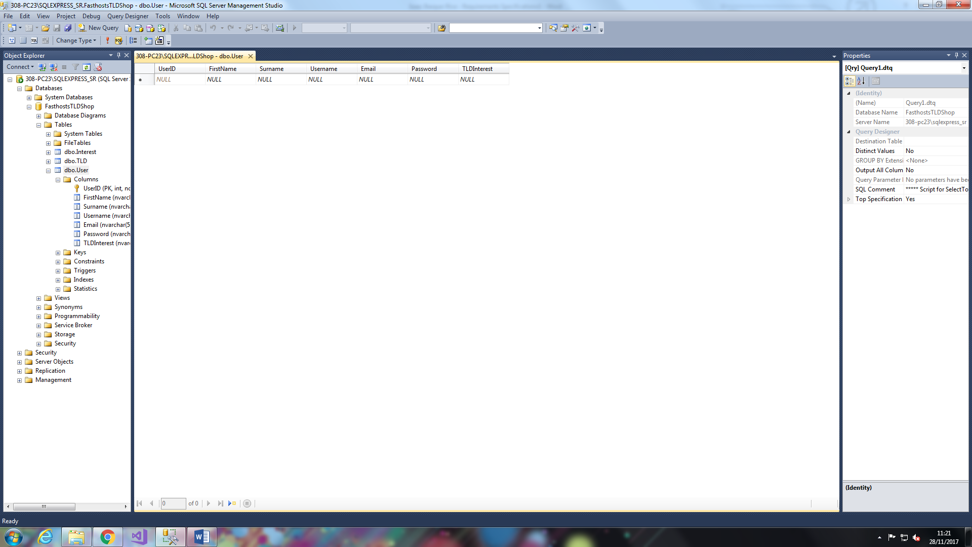

Figure 8

Figure 8 is a screenshot of the first of the three tables, the user table. This table is set aside as the table into which the user directly inputs through a webform set out on the front end of the website. Within this webform are several columns designed to collect data from the user. This data is collected for three distinct and separate reasons:

1. In order to allow for logon: arguably the most important reason for user data collection, at least from the perspective of the user. Data from the table is cross-referenced with other data from the table in order to allow entrance into the account (for example a correct username/email and password combination)
2. In order to personalise the user experience: Server-side scripting (in my case ASP.net) used in conjunction with information pulled from the database can result in personalised UXs, for example, a box in the corner that says ‘welcome back, [user]!’
3. In order for the website creator to, for example, tailor an information stream to you: data, such as an email address, is collected on a user in order for the website creator to use that information however they see fit, for example, they could create some form of mailing list with users in order to give them information about the further development process, issues, or other such information that may be necessary to the user.

The UserID column is, however, different to the rest of the columns, not least due to the fact that an ‘**int**’ data type is ascribed to it (as opposed to the ‘**nvarchar**’ data type ascribed to the remaining columns), but also due to the fact it is the only column on this table that the user does not directly input any information into.

The reason behind the int attribute being ascribed to this column, as well as the inability for the user to input the information, is as follows: upon the creation of a profile on the website, a User ID is given to the user, this allows the server to relate the user to their registered TLD interest through the usage of primary and foreign keys (as seen in figures 10 and 11 and as described below). The user is not able to input the information because I am legally obligated not to share information about other users with any single user or group of users (under the data protection act), and as such they are unaware of any of the other user IDs, so they cannot be sure they are inputting a unique user ID, which is integral to the whole system.

The UserID column, along with every other column bar TLD interest, does not allow **Nulls**. The reason TLD interest allows nulls where the rest do not is due to the fact that giving some TLDs that you are already interested in is not and should not be necessary for the creation of an account with my TLD registry site, however the rest of the information is. Indeed, the lack of information in the TLD interest section, for some users, is in itself a piece of information, that is to say that we will be able to discern those users who intended to register a TLD before registering with my site, and see the registry as just a formality, with those users who create an account merely to browse possible TLDs, and have no TLDs in mind, at least in theory.

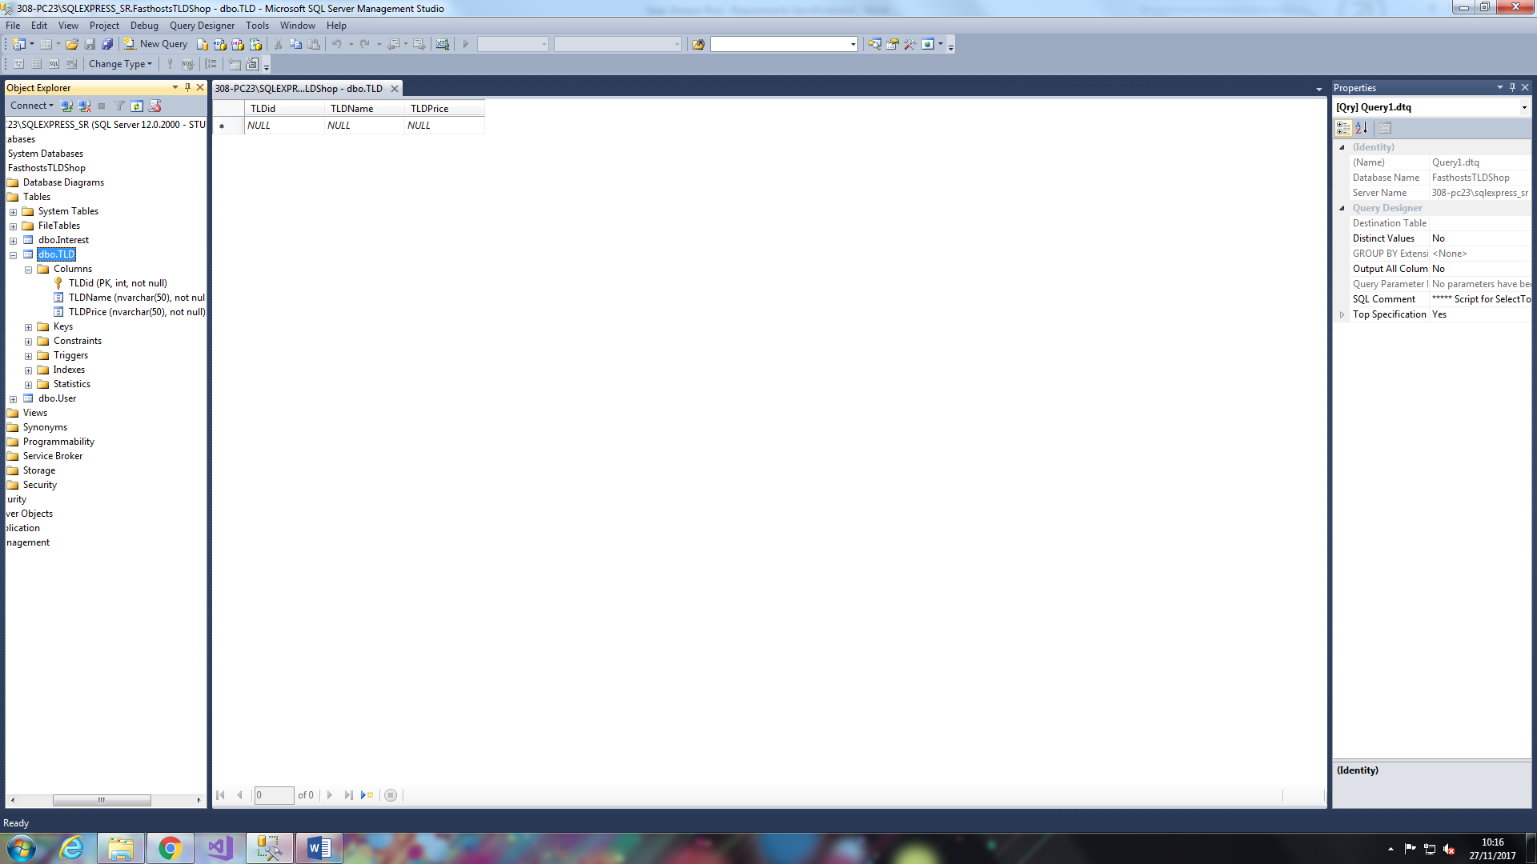

Figure 9

Figure 9 is the TLD database, it comprises of three columns: TLDID, Name, and Price. As with the Users table, TLDID, the primary key for the table, is set to have an ‘int’ data type in order to distinguish it from others when used outside the context of the table. In addition to this the Name and Price columns are self-explanatory, the name of the TLD (data type nvarchar (50)) will comprise of a word preceded by a full stop or period, for example, ‘.com’, ‘.org’, ‘. co.uk’, in the same fashion they would be seen in-browser.

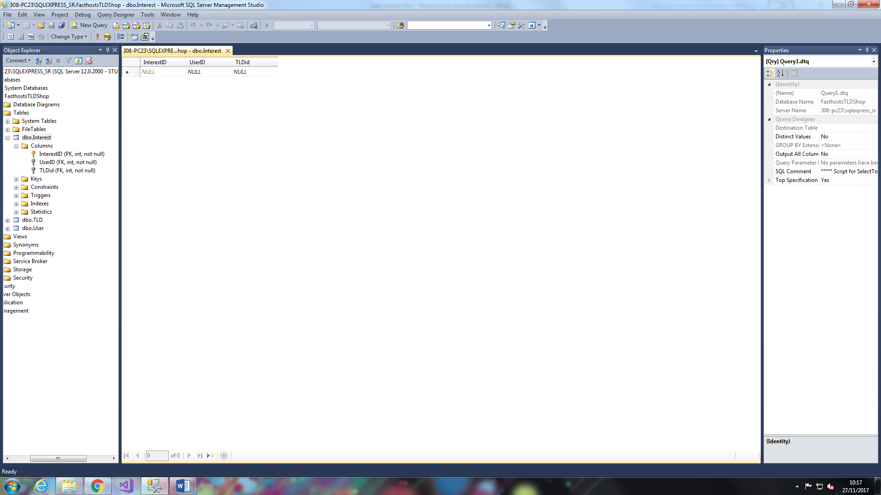

Figure 10

Figure 10 depicts a table that is a significant degree more interesting than the previous two, this is due to the fact that in addition to the primary key (InterestID in this case) the other two columns comprise of the data from primary keys from the other two tables, which are known as ‘foreign’ keys in the context of the Interest table. To this end, the interest table serves as a sort of bridge between the other two tables, it links the user to the TLDs they have expressed interest in by associating the ID of the user with the ID of the TLD they have expressed interest in. that association has its own separate ID (InterestID) that one may refer to beyond the context of the database.

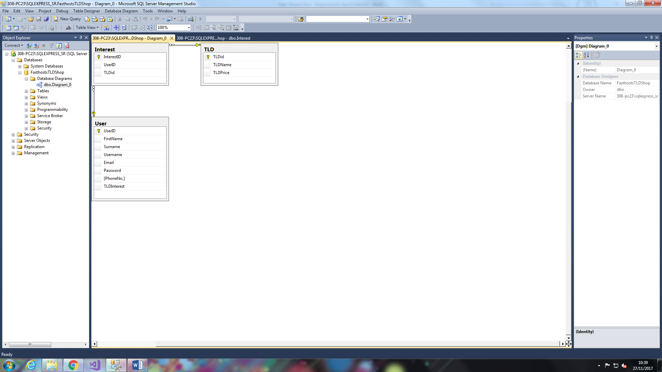

Figure 11

Finally, figure 10 displays a diagram of the database and the relations between separate tables within said database, the diagram is a more visual way of explaining what I have described above under figure 10, in that the Interest table is linked to the other two table through the use of primary and foreign keys.

# Development

This section of my document will essentially serve as a diary and, as such, a reference for the development of my solution, it will contain HTML, CSS, ASP.net, and any other code necessary for the development of the website. In addition to this, noteworthy tests that I undertake for the website will be logged within this section. Upon the discovery of a fault in my program I will attempt to fix the fault and log precisely what the fault was, why it was there, and how I fixed it. It will also include descriptions and uses of every page within the solution (predicted to be 6 pages total), and include screenshots for every version of each page.

It is important to note however that text may be kept to a minimum in this section both to focus on development itself, and for the reason that screenshots may be self-explanatory.

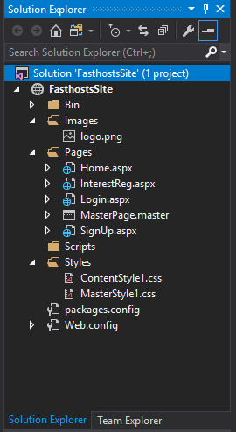

Screenshot 1

Figure 12

Figure 12 represents a list of files I have created pre-emptively, at the point of creating my solution. In here I have created 4 folders, Images, Pages, Scripts, and Styles. Within the Images folder I have The Fasthosts logo in PNG form, within Pages I have 4 content pages (Home, InterestReg, Login, and SignUp), and 1 Master Page (the content of which will be applied to every page). Within the Scripts folder I have nothing due to the fact that different scripts will be tailored for specific events in my solution and given how these are not precisely predicted I thought it best to leave it empty for the time being and add as and when is required. Finally, we have the styles folder which contains stylings for both the content pages and the master page separately as to be able to differentiate.

## Pages

Within my solution will be several separate pages designed to meet the different requirements of the specification, the home page will house the carousel, which is designed specifically to fulfil several requirements, specifically the media and JavaScript aspects. The TLDs page will be a searchable list of top level domains, pulled from a database, and displayed for the user to browse. Next comes the Contact Us page designed to specifically fulfil the requirements pertaining to JS validation. The final two link in with each other, the sign up page allowing users to input their own information into a database, and the login page allowing users to sign in to their accounts from the username in password they have inputted into the database.

The following is a more in-depth analysis of the different pages and their individual functions.

## Master page

### Header

In order to keep to the design that I have laid out in section 2.2, I decided to separate two distinct unordered lists by making use of the <div> tag, as such:

<header>

<div class="head">

<img src="../Images/logo.png" alt="Fasthosts Logo" />

<ul>

<li><a href="#">Blog</a></li>

<li><a href="#">Support</a></li>

<li><a href="#">Switch Theme</a></li>

</ul>

</div>

<div class="nav">

<ul>

<li><a href="#">Home</a></li>

<li><a href="#">TLDs</a></li>

<li><a href="#">Login</a></li>

<li><a href="#">Sign Up</a></li>

</ul>

</div>

</header>

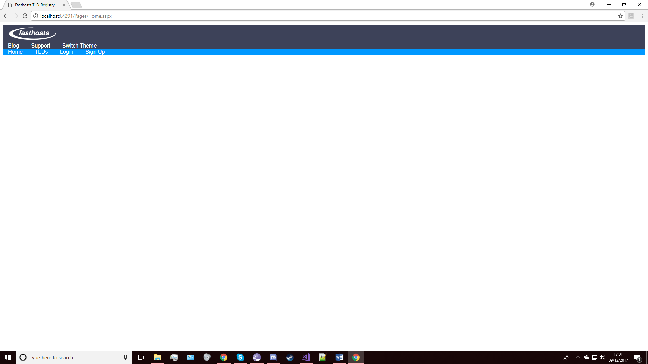

Screenshot 2

Screenshot 1 is the result of the very first successful test, as conducted on 09/12/2017, continuing development of the header, I intend to have the links in the top section of the header to be in-line with the logo, and for both sections to be wider than they currently are. In addition I will add link functionality to a select few links, which I will link to the original website.

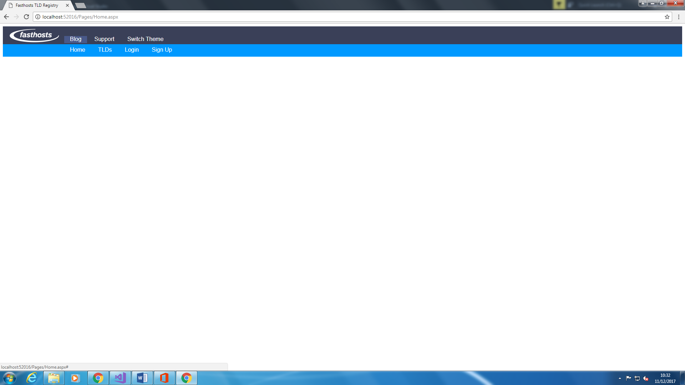

Screenshot 3

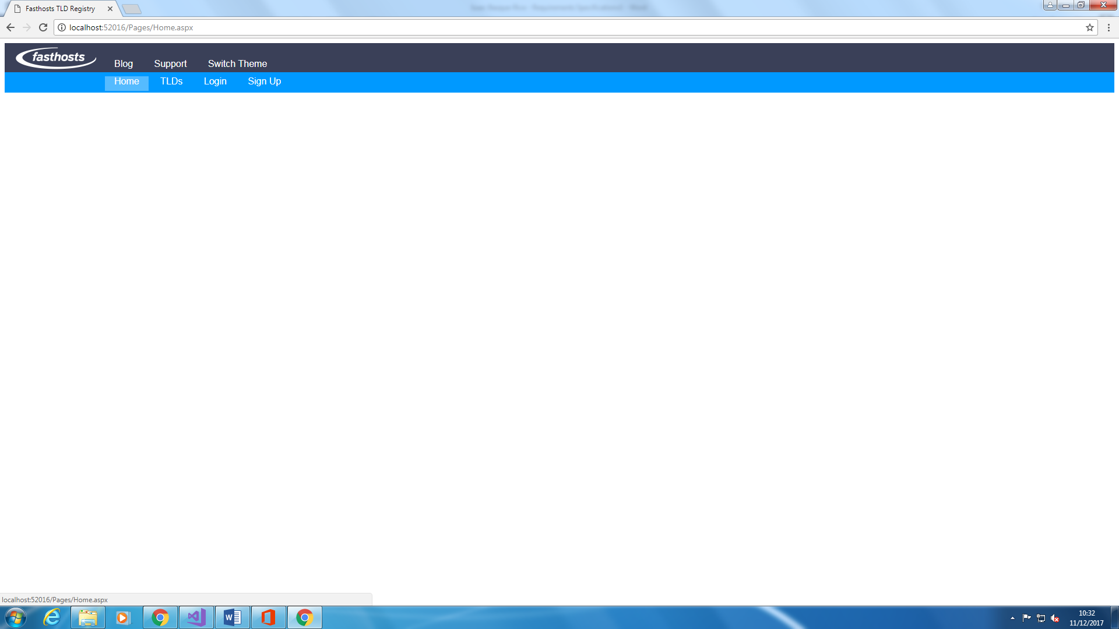

Screenshot 4

In this next update I have added the functionality for the four nav bar links to link to other sections of the website on click, in addition to this, on hovering over the links, the background colour changes to a lighter colour, to signify that you have, indeed, hovered over it.

### Footer

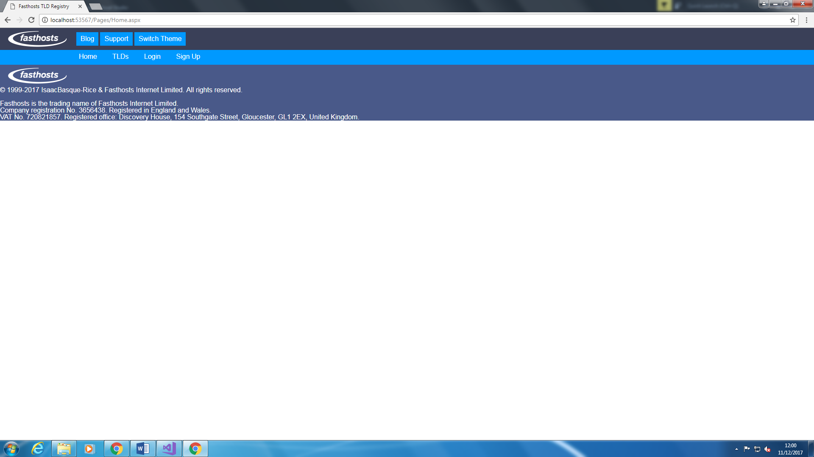

Screenshot 5

Working version of the master page without any content, changes I have to make pertaining specifically to the footer are twofold: firstly I need to transform the content (the legalese) over to be in line with the logo, and secondly I need to add the three links on the right side of the screen.

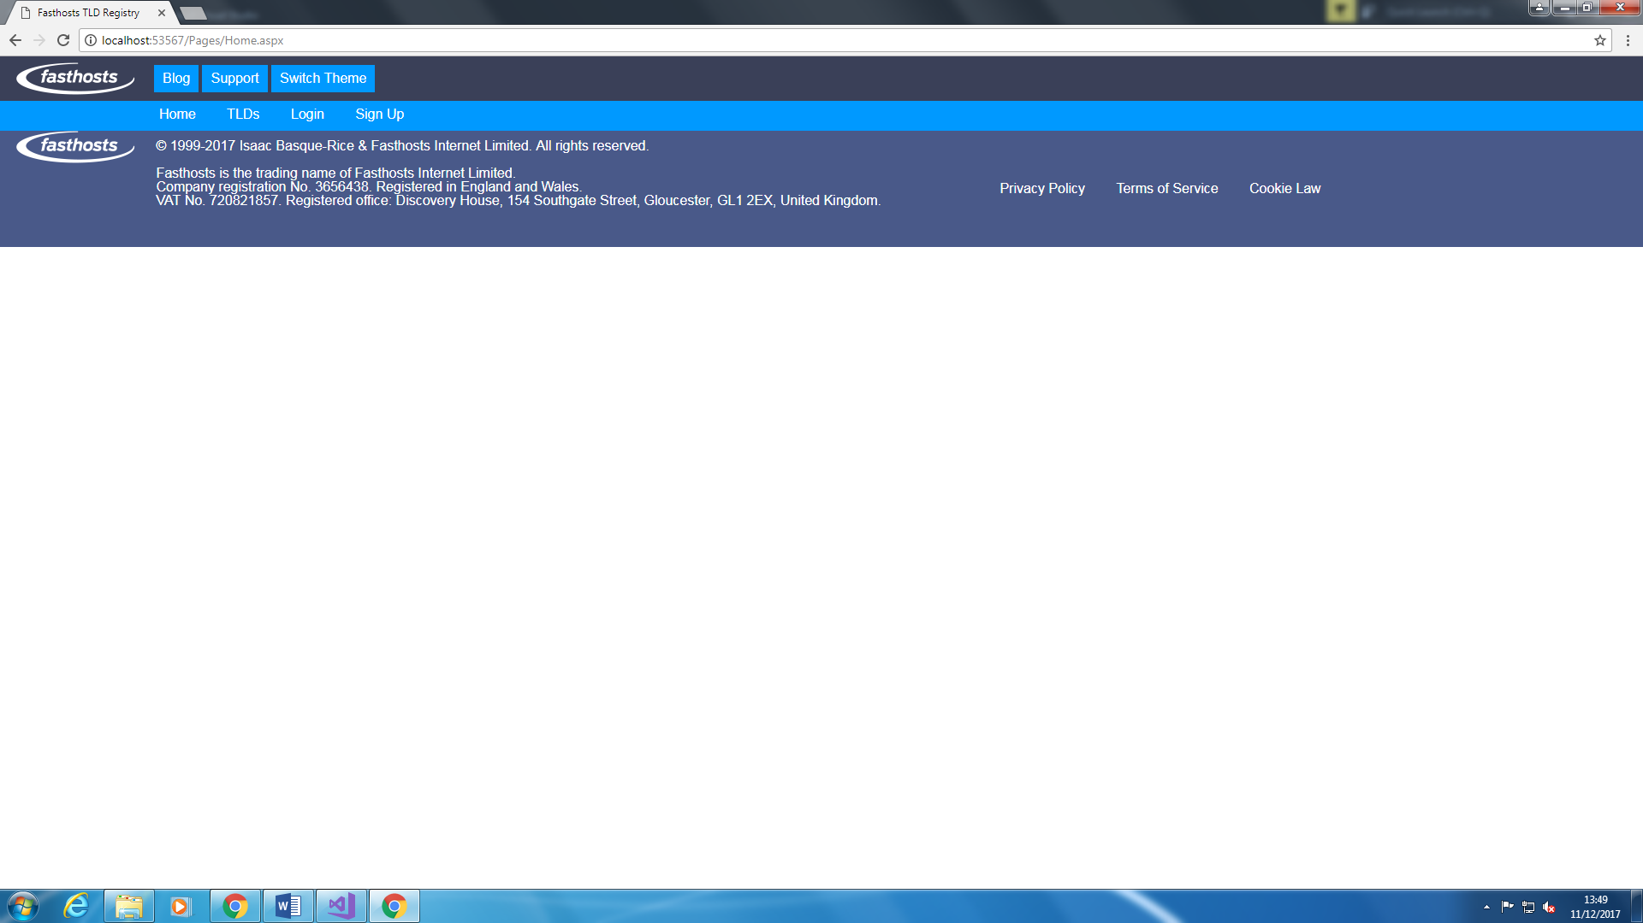

Screenshot 6

The final (planned) version of the master page, there may be a few revisions however I believe this basically how the final version should look.

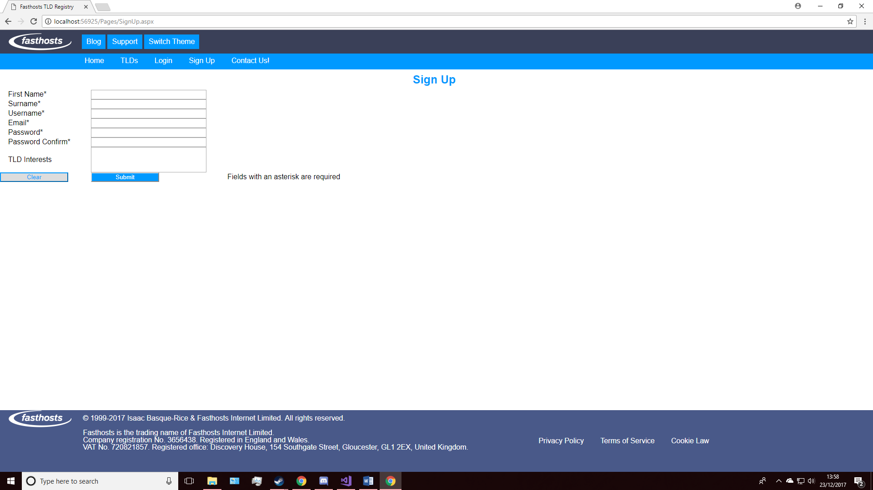

Screenshot 7

This screenshot demonstrates a revision I have undertaken with the footer, notice how instead of being directly below the content it is instead at the bottom of the page.

### Styling

A single style sheet pertaining to the entire solution was attached to the master page in order for every single element required throughout the solution to be styled in the same way depending on what element they are, for example, every h1 element is styled as follows:

h1 {

color: #0099ff;

text-align: center;

font-size: 25px;

padding: 10px 10px 10px 0px;

}

This simplifies the solution, having everything in a css file attached to the master page decreases workload and streamlines the work proess.

### Time/Date

In order to fulfil the third-party JavaScript library requirement within the spec, I have made the decision to implement a time/date counter using a library called ‘moment.js’.

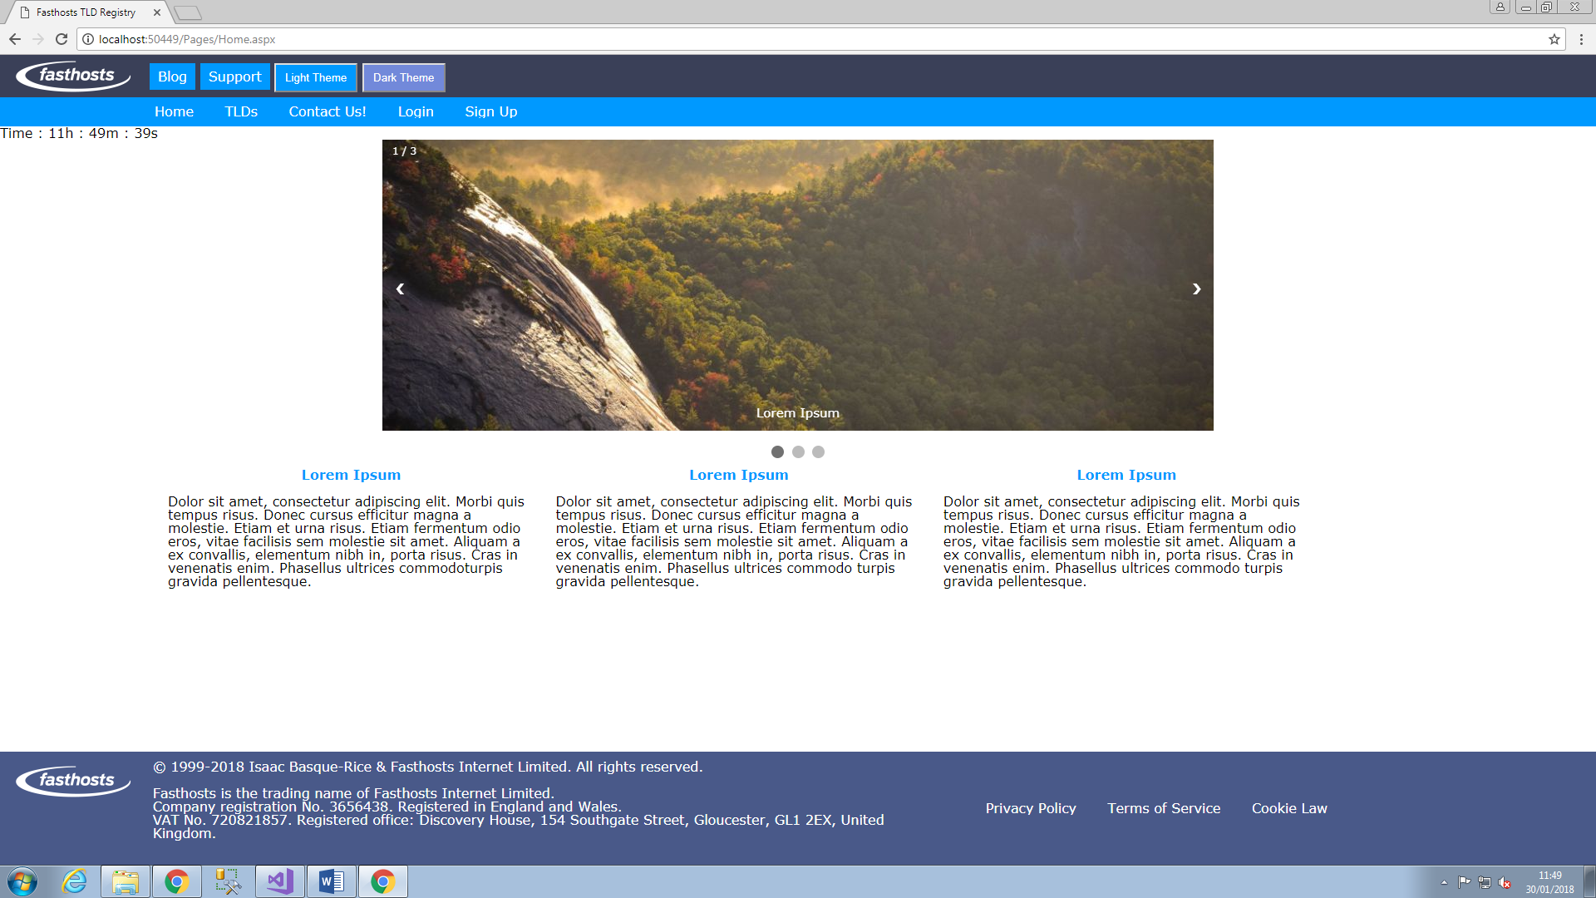

Screenshot 8

At the top, just below the nav bar, a self-updating time counter using moment.js.

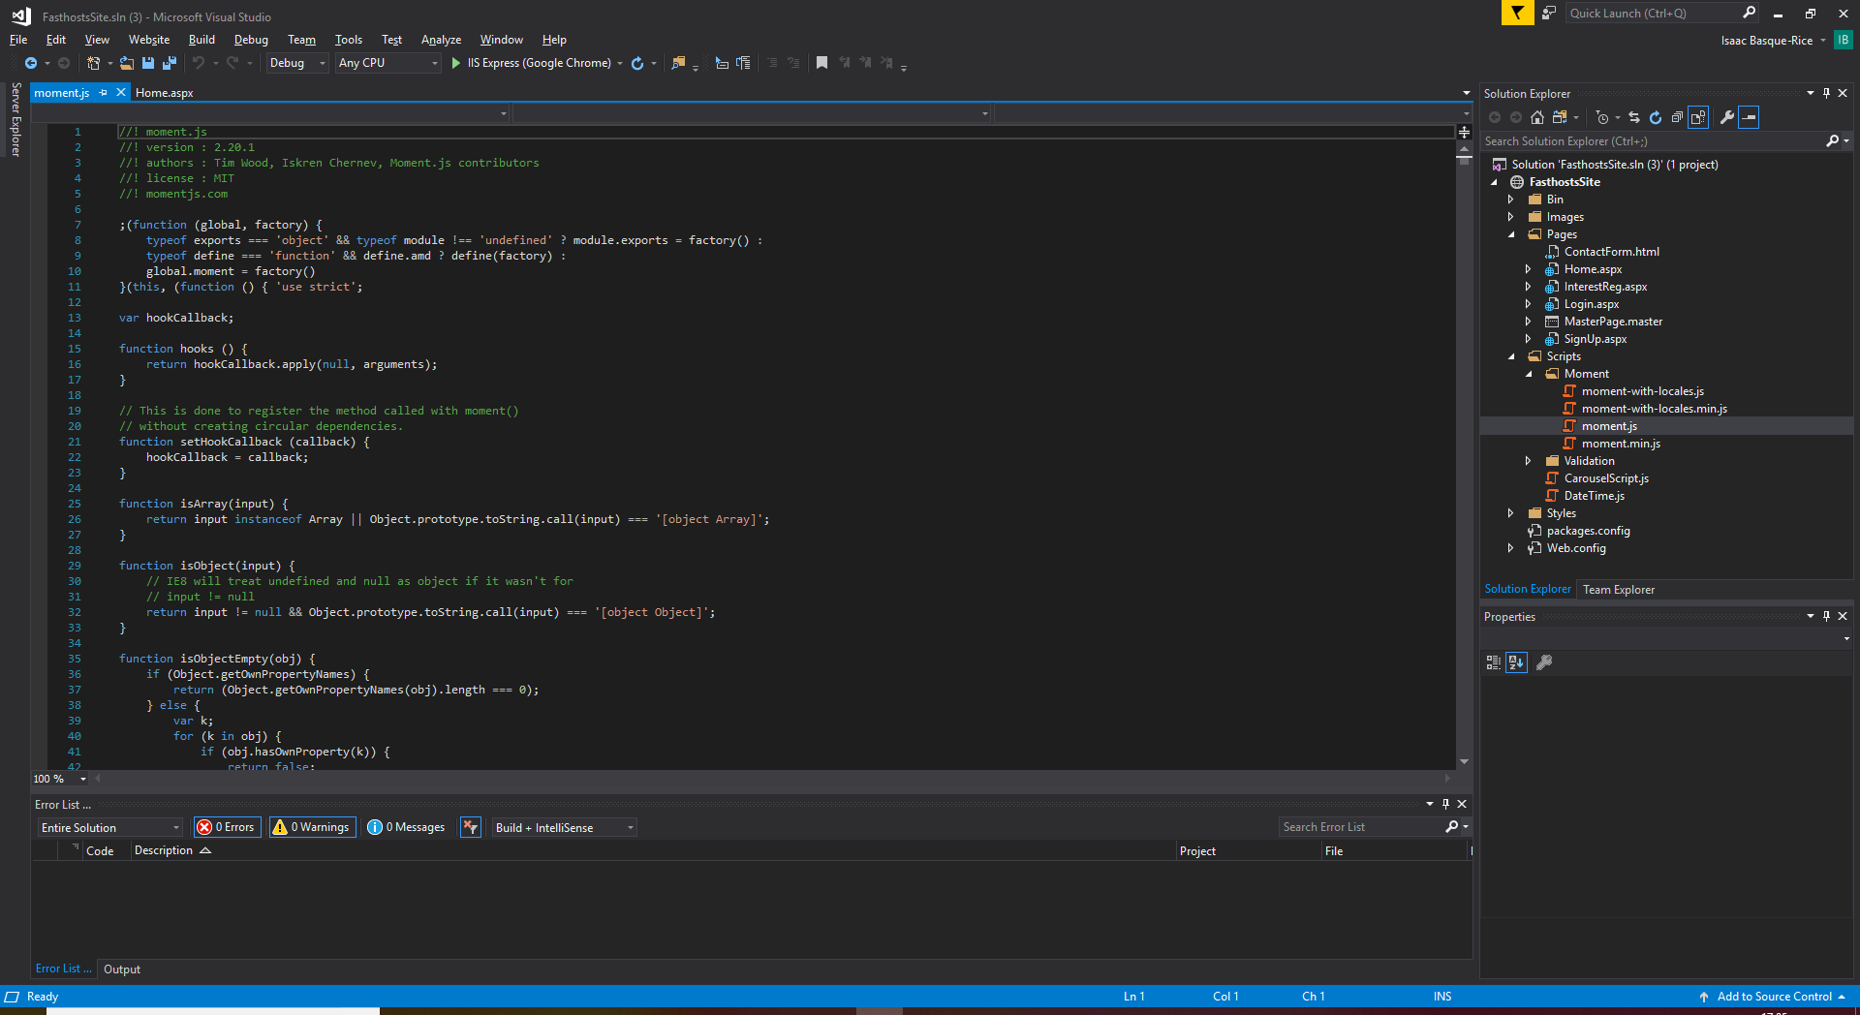

Screenshot 9

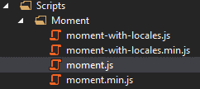

Screenshot 10

The above screenshots are of the files within the moment.js library folder, which I implemented for the counter, the former being the specific moment.js file, which I called in the JavaScript function I wrote in order to increment the timer.

function updateClock() {

//moment() means I'm calling moment.js

var now = moment(),

second = now.seconds();

document.getElementById("time").innerText = "Time : " + now.hours() + "h : " + now.minutes() + "m : " + now.seconds() + "s";

//updates the clock every 1000ms (1s)

var t = setInterval(updateClock, 1000);

}

Above is the JavaScript function which calls the timer and increments it.

### Issues

* The first issue I have come into is the fact that when I attempt to debug the website, nothing will appear on the screen, it would merely be a blank screen, as seen here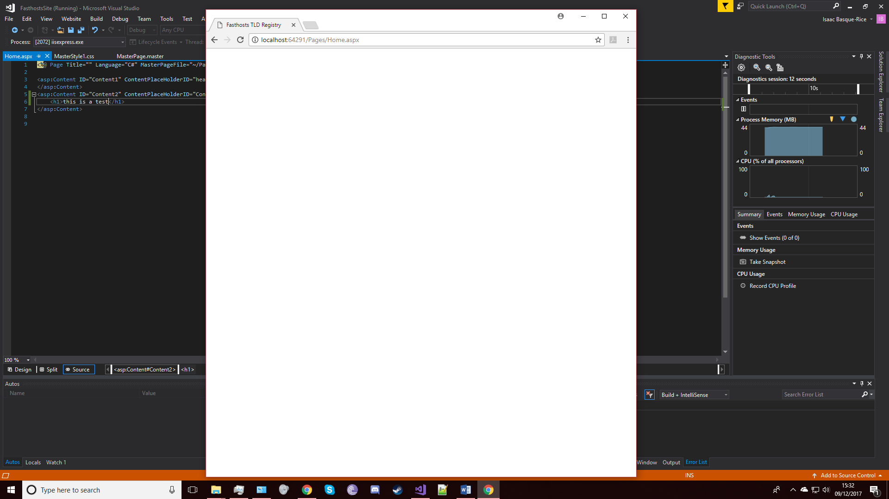

Issue Screenshot 1

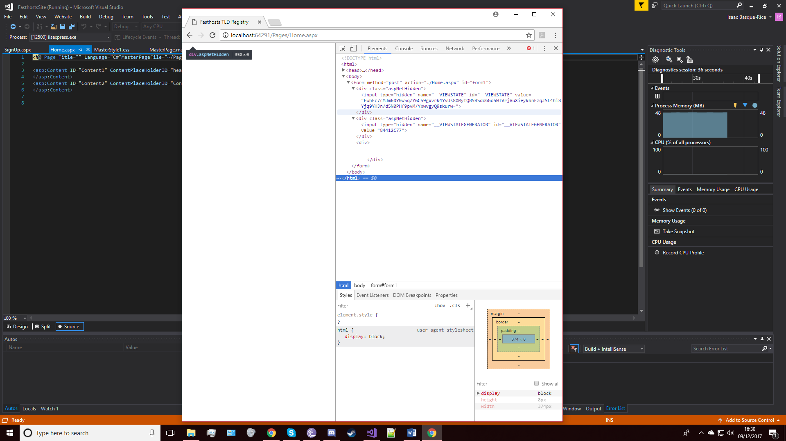

Issue Screenshot 2

As you can see in the screenshot above, an issue is occurring that results in the fact that not only is my code not appearing, but also an error of some kind seems to have appeared

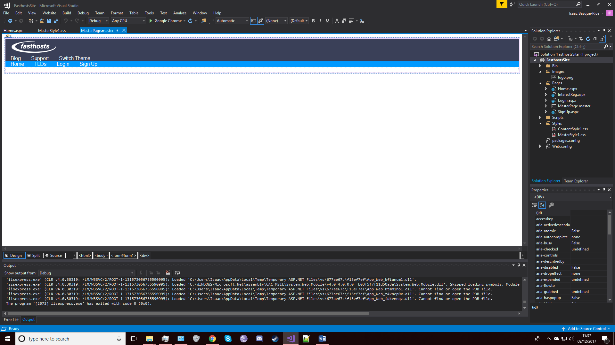

Issue Screenshot 3

As you can see in the screenshot above, the design mode in visual studio works perfectly for displaying content.

Fix:

I had accidentally placed my code within the asp:ContentPlaceholders, moving the code outside of it yielded positive results

* 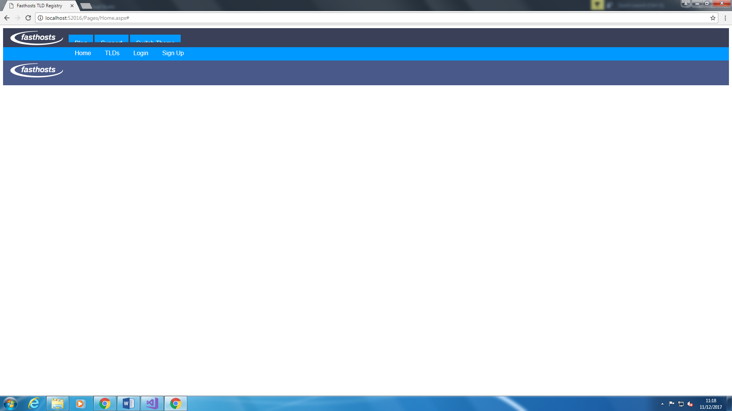

Issue Screenshot 4

The next issue comes with the surrounding boxes within the header

Fix: it was fixed by increasing the height of the links and decreasing the padding

An additional issue is JavaScript and Third-Party-Library based, namely, Moment.js’s syntax

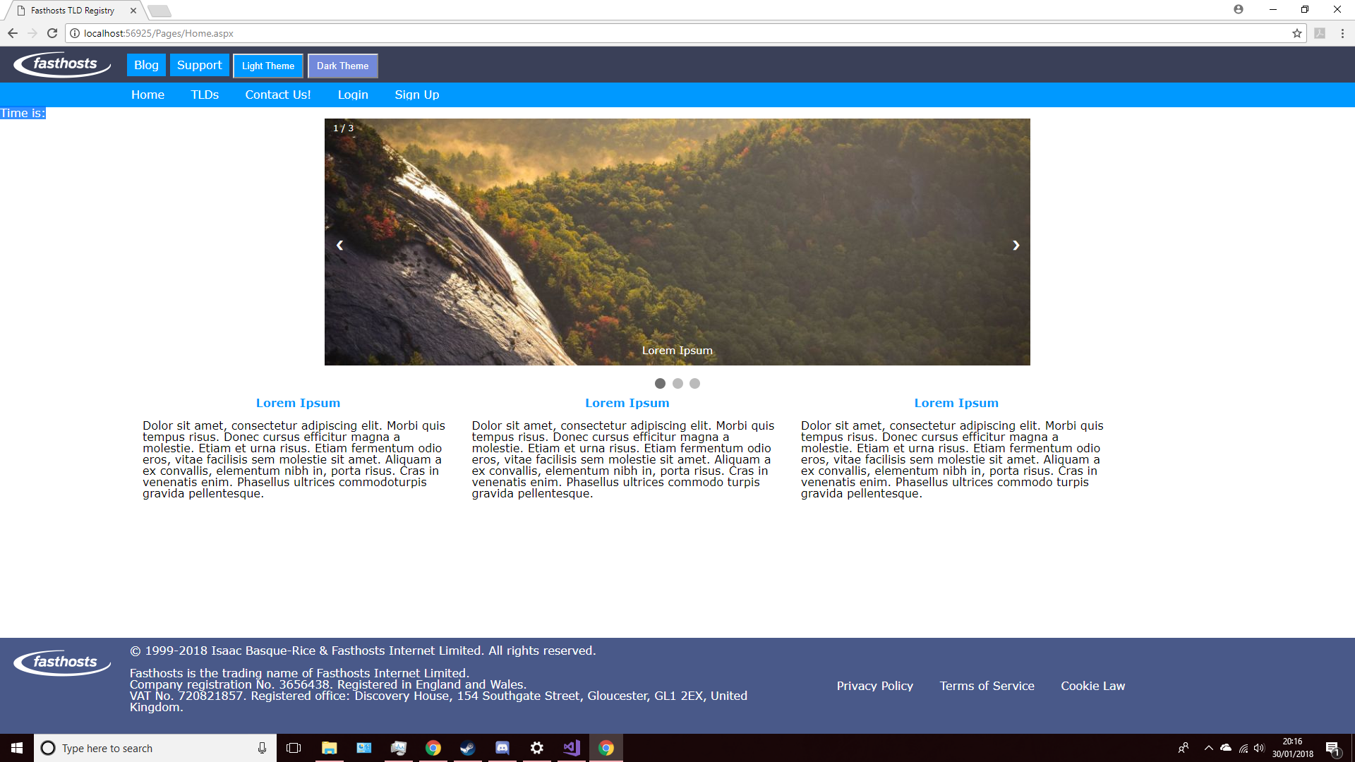

Issue Screenshot 5

Noticeably highlighted is the lack of time within the highlighted area, this is due to the following Moment code:

function updateClock() {

moment().format('MMMM Do YYYY, h:mm:ss a');

moment().format(String);

this creates a function known as updateClock, which I can refer to in the HTML code. What I was under the impression would happen is that on load the full time and date would be generated and then proceed to be turned into a string on line 3, however the end result was simply a lack of time displayed.

The solution came in the form of the following code:

function updateClock() {

//moment() means I'm calling moment.js

var now = moment(),

second = now.seconds()

document.getElementById("time").innerText = "Time : " + now.hours() + "h : " + now.minutes() + "m : " + now.seconds() + "s";

//updates the clock every 1000ms (1s)

var t = setInterval(updateClock, 1000);

}

As you can see, the function (updateClock) remains the same, however in this instance I make use of the p id=”time” tag and attribute. The id is referenced using the getElementById method, the inner text makes use of moment.js’s now.[timeframe] methods (now.hours(), now.minutes() etc.), with a colon between each interval.

The final line of code sets a variable t to set the refresh interval of the updateClock function to 1000ms, meaning that every 1 second exactly, the function repeats itself, thereby updating the clock.

In my website solution this functions perfectly well, as the example screenshots below show:

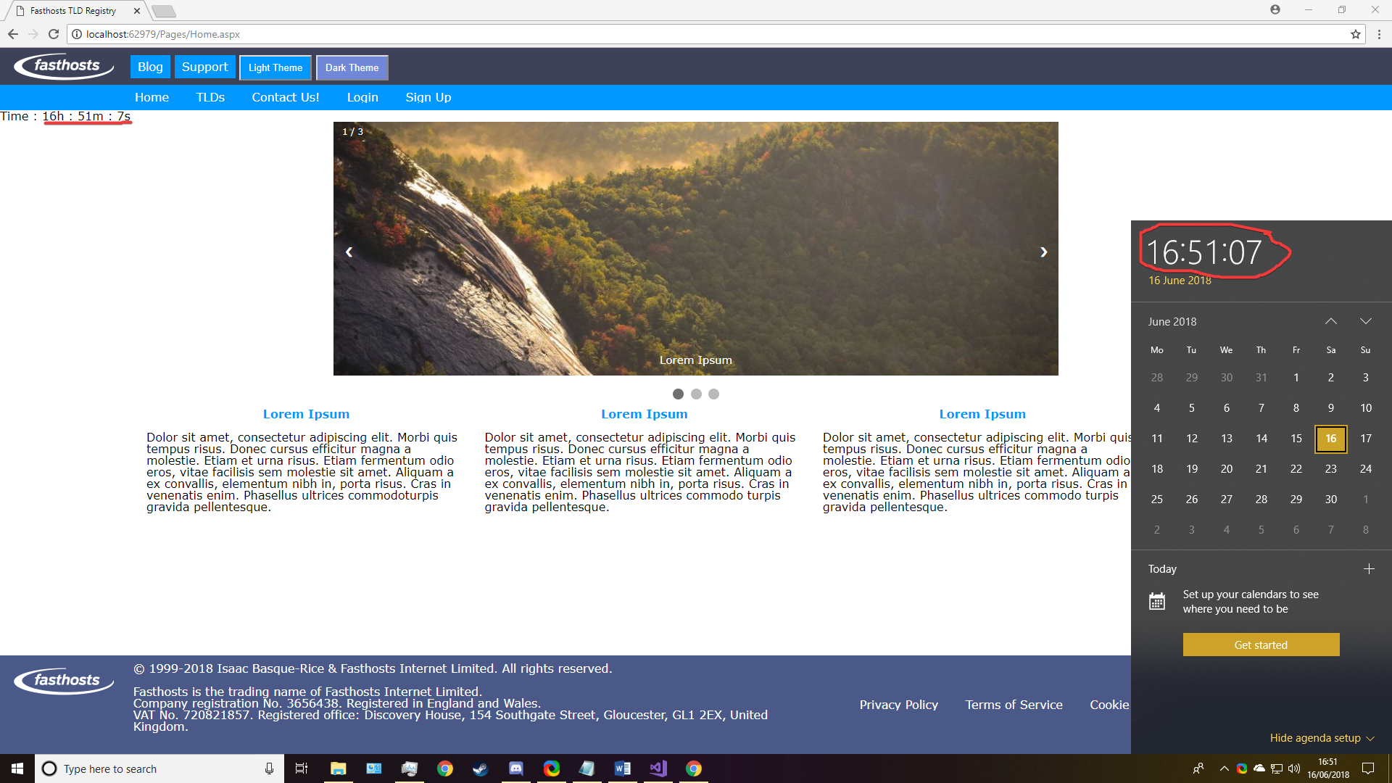



Screenshot 11

## Homepage

### Carousel

For the Carousel I wrote the relevant amount of JavaScript code that allowed me to include the features necessary in this case, for example the ability to move left or right and the ability to know which photo you’re on.

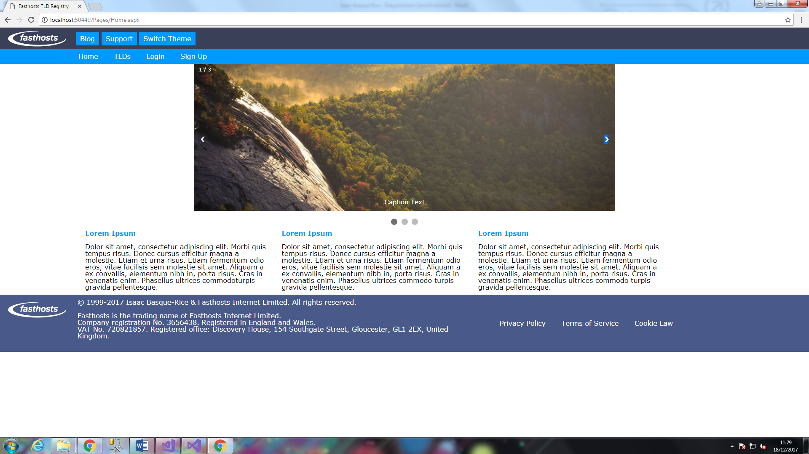5

Screenshot 12

As you can see in the screenshot above, there are three dots at the bottom of the carousel to indicate the three images, one of these dots corresponds to the image the user is currently on. There are two arrows layered over the image, one pointing left and one pointing right, these two arrows correspond to what direction the user wants to move along the carousel. Upon hovering the arrows’ backgrounds turn translucent black. Finally, in the top left-hand corner of the carousel there is a number corresponding to what image you are on at the current time. The ability to move between images affords the user a certain degree of interactivity within the website.

Each image is under the same div class, ‘mySlides’, and within this div exist div classes for the individual images, their image sources, and text to go with it (including numbering and caption text).

### Content

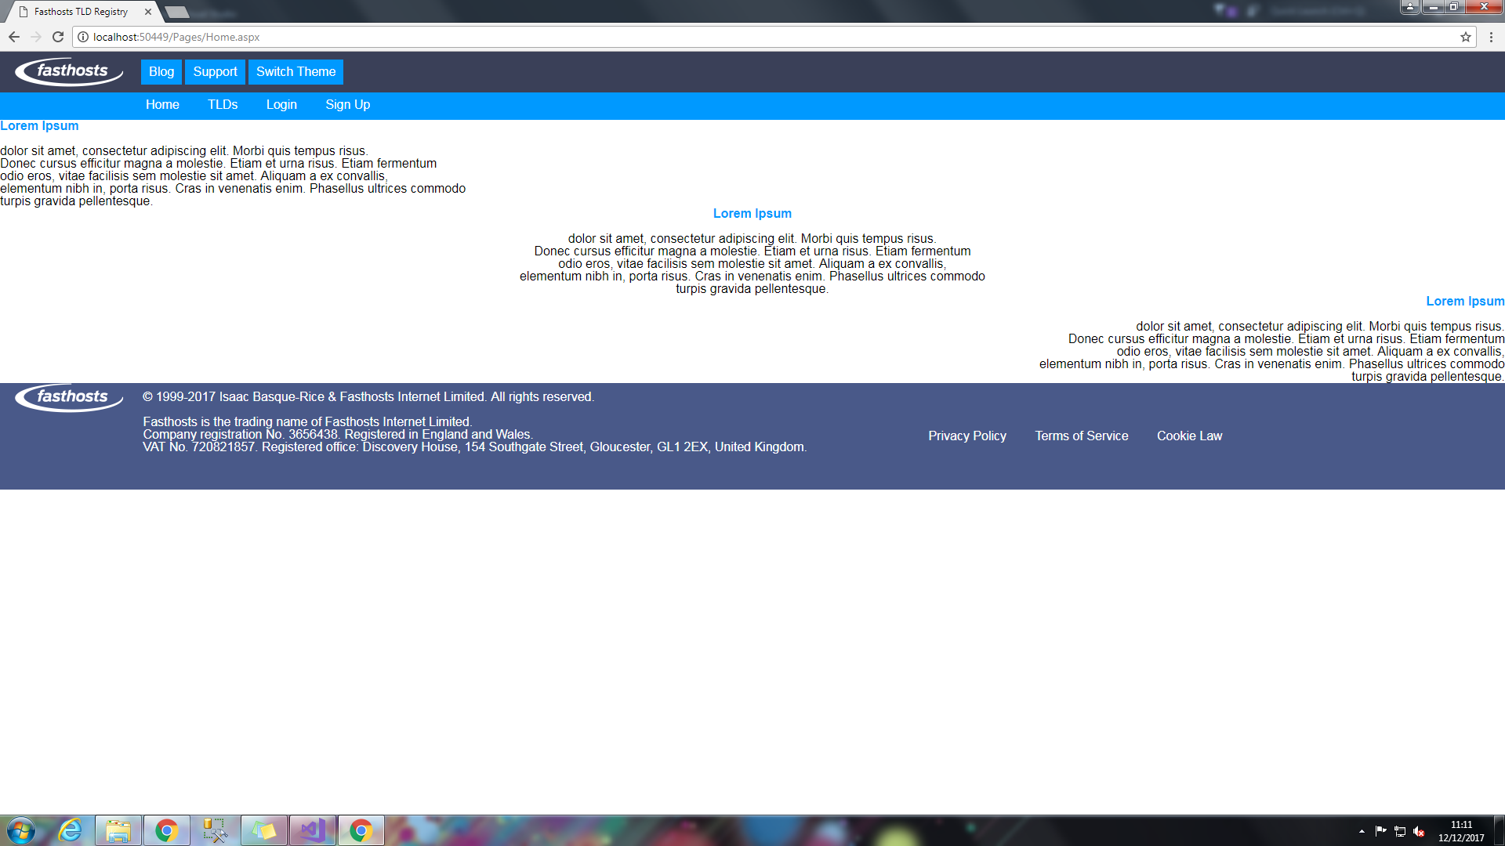

Screenshot 13

The content in this section has been separated into three divs, left1, centre1, and right1, and text-aligned to their corresponding areas, in addition to this the content itself is mainly comprised of **Lorem Ipsum** so as to demonstrate the capabilities of the site rather than finding genuine content.

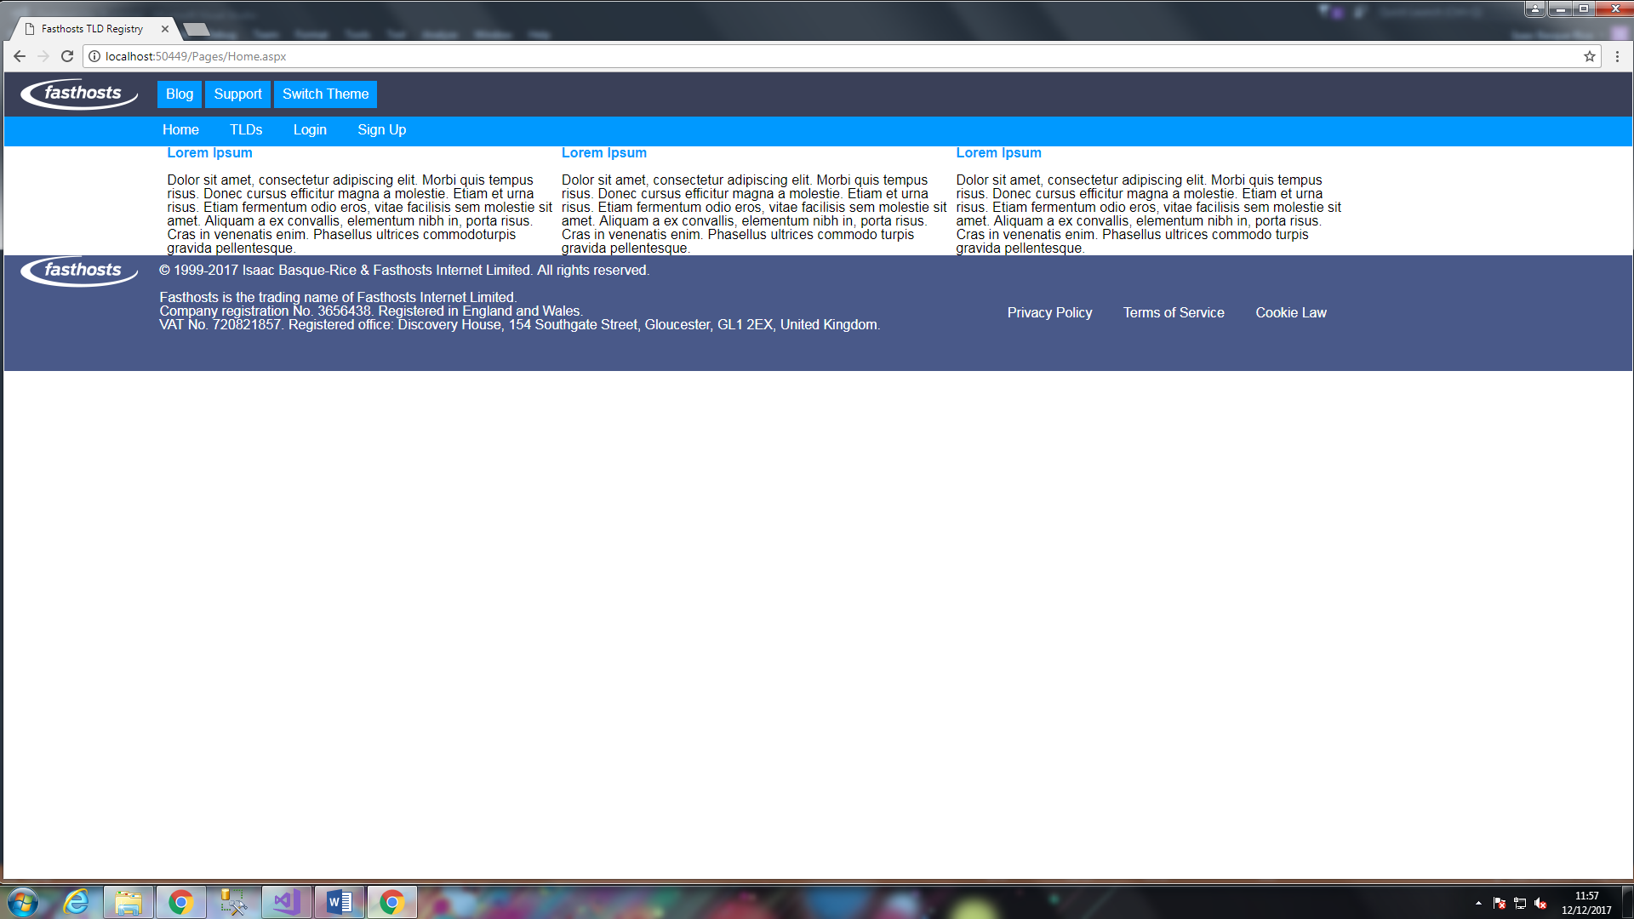

Screenshot 14

Within this page as a whole we have two separate sections, the carousel and the content, as such they are separated by using two sets of <section> tags (as can be seen within the source code of the beginning and end of this section). The <section> tag is HTML5 specific, making its debut in version 5.

Additionally, further new elements to HTM5 mainly concern the usage of media content, with <video>, <audio>, <embed>(defining a container for an external app), and <track> (defines text tracks for media content) elements making their debut in this incarnation of HTML. Additionally, the usage of <article>, <footer>, <header>, and <section> tags in HTML5 constitute a significant increase in article specific content, with the <article> and <section> tags specifically being examples of this. Finally, <header> and <footer> tags work to make the formation of header and footer content more streamlined (W3Schools, n.d.)

The following is a code example within my solution, with the HTML5 specific aspects (section tags specifically) emboldened and underlined:

**<section>**

<div class="slideshow-container">

<div class="mySlides fade">

<div class="numbertext">1 / 3</div>

<img src="https://www.w3schools.com/howto/img_nature_wide.jpg" alt="Image 1" style="width:100%">

<div class="text">Lorem Ipsum</div>

</div>

<div class="mySlides fade">

<div class="numbertext">2 / 3</div>

<img src="https://www.w3schools.com/howto/img_fjords_wide.jpg" alt="Image 2" style="width:100%">

<div class="text">Dolor Sit Amet</div>

</div>

<div class="mySlides fade">

<div class="numbertext">3 / 3</div>

<img src="https://www.w3schools.com/howto/img_mountains_wide.jpg" alt="Image 3" style="width:100%"/>

<div class="text">Consectetur Adipiscing Elit</div>

</div>

<a class="prev" onclick="plusSlides(-1)">&#10094;</a>

<a class="next" onclick="plusSlides(1)">&#10095;</a>

</div>

<br>

<div style="text-align:center">

<span class="dot" onclick="currentSlide(1)"></span>

<span class="dot" onclick="currentSlide(2)"></span>

<span class="dot" onclick="currentSlide(3)"></span>

</div>

**</section>**

**<section>**

<div class="content1">

<div class="text-box">

<h1>Lorem Ipsum</h1>

<br />

<p>Dolor sit amet, consectetur adipiscing elit. Morbi quis tempus risus. Donec cursus efficitur magna a molestie. Etiam et urna risus. Etiam fermentum odio eros, vitae facilisis sem molestie sit amet. Aliquam a ex convallis, elementum nibh in, porta risus. Cras in venenatis enim. Phasellus ultrices commodoturpis gravida pellentesque.</p>

</div>

<div class="text-box">

<h1>Lorem Ipsum</h1>

<br />

<p>Dolor sit amet, consectetur adipiscing elit. Morbi quis tempus risus. Donec cursus efficitur magna a molestie. Etiam et urna risus. Etiam fermentum odio eros, vitae facilisis sem molestie sit amet. Aliquam a ex convallis, elementum nibh in, porta risus. Cras in venenatis enim. Phasellus ultrices commodo turpis gravida pellentesque.</p>

</div>

<div class="text-box">

<h1>Lorem Ipsum</h1>

<br />

<p>Dolor sit amet, consectetur adipiscing elit. Morbi quis tempus risus. Donec cursus efficitur magna a molestie. Etiam et urna risus. Etiam fermentum odio eros, vitae facilisis sem molestie sit amet. Aliquam a ex convallis, elementum nibh in, porta risus. Cras in venenatis enim. Phasellus ultrices commodo turpis gravida pellentesque.</p>

</div>

</div>

**</section>**

### JavaScript

The JS in this section of the website corresponds entirely to the carousel, allowing functionality to move along the images at will (by clicking the right arrow the script increases n where n is the image number, by clicking the left arrow it does the opposite, wrapping back around from 3 to 1), code for this is demonstrated below:

var slideIndex = 1;

showSlides(slideIndex);

function plusSlides(n) {

showSlides(slideIndex += n);

}

function currentSlide(n) {

showSlides(slideIndex = n);

}

function showSlides(n) {

var i;

var slides = document.getElementsByClassName("mySlides");

var dots = document.getElementsByClassName("dot");

if (n > slides.length) { slideIndex = 1; }

if (n < 1) { slideIndex = slides.length; }

for (i = 0; i < slides.length; i++) {

slides[i].style.display = "none";

}

for (i = 0; i < dots.length; i++) {

dots[i].className = dots[i].className.replace(" active", "");

}

slides[slideIndex - 1].style.display = "block";

dots[slideIndex - 1].className += " active";

}

### Issues

The first issue I have found is the fact that the three divs, x1, where x is their text-alignment values, are not in line with each other, as was my desired effect, in addition the lines within these divs are not of the same length, this can be fixed by measuring the string length within each of the <p> tags to have them of equal length.

Ultimately, the fix was to not have them in three separately named divs, but three separate divs with the same name, ‘text-box’

The next issue I have come across is the fact that on loading the carousel, the first image does not load and you have to scroll through the images in order for an image to display.

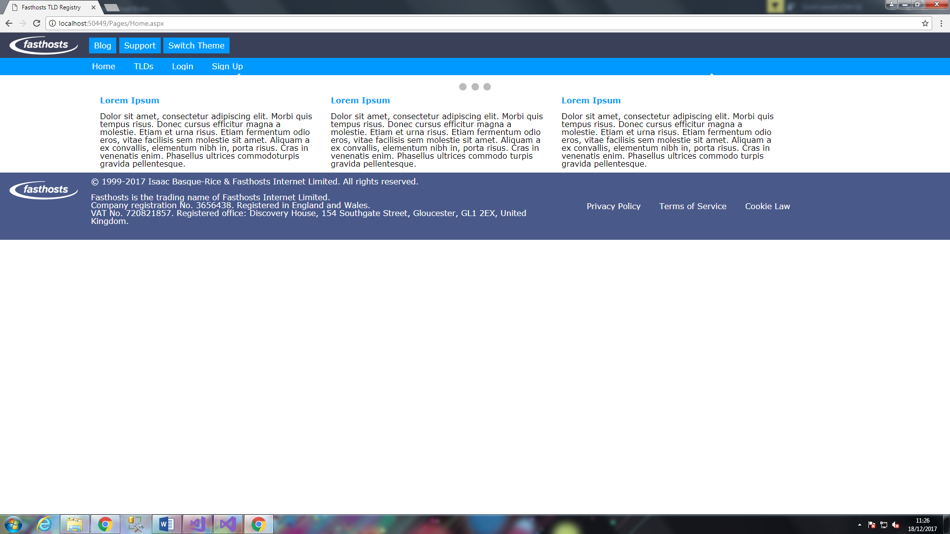

Issue Screenshot 6

A fix came in the form of a line of C# in the [Home.aspx.cs](http://Home.aspx.cs) file within my solution, the line is as follows:

ClientScript.RegisterStartupScript(this.GetType(), "test", "currentSlide(1)", true);

Later on, another issue occurred that caused the exact same problem, and additionally affected my timer, as added towards the end of the build.

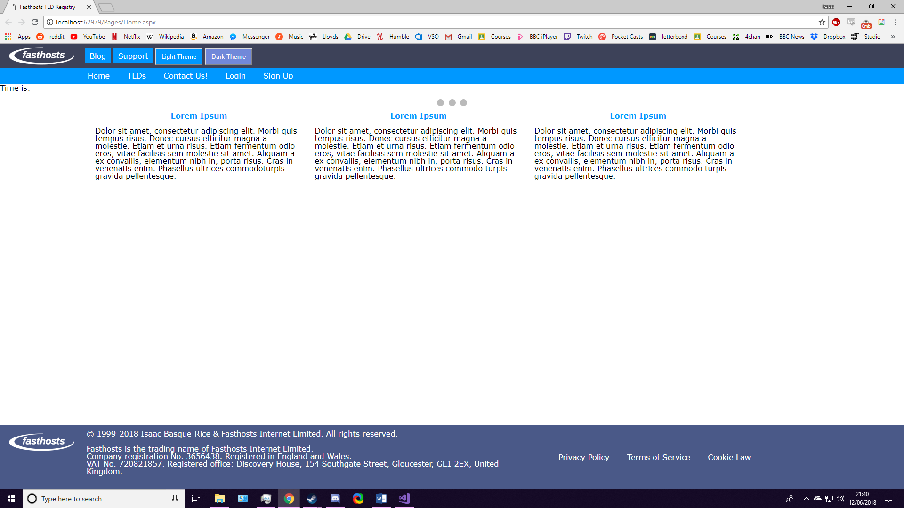

Due to the fact that this had also affected my timer, it was obvious that a Javascript error was to blame, I combed through my code and placed a breakpoint fairly early on in my program, line 5 of the carousel script, and I found that instead of a “+=” operator, denoting that something equals another thing added to the first thing (x+=y Is the same as x = x+y), rather I had placed a “!=” operator, signify that one thing does not equal another, as so:

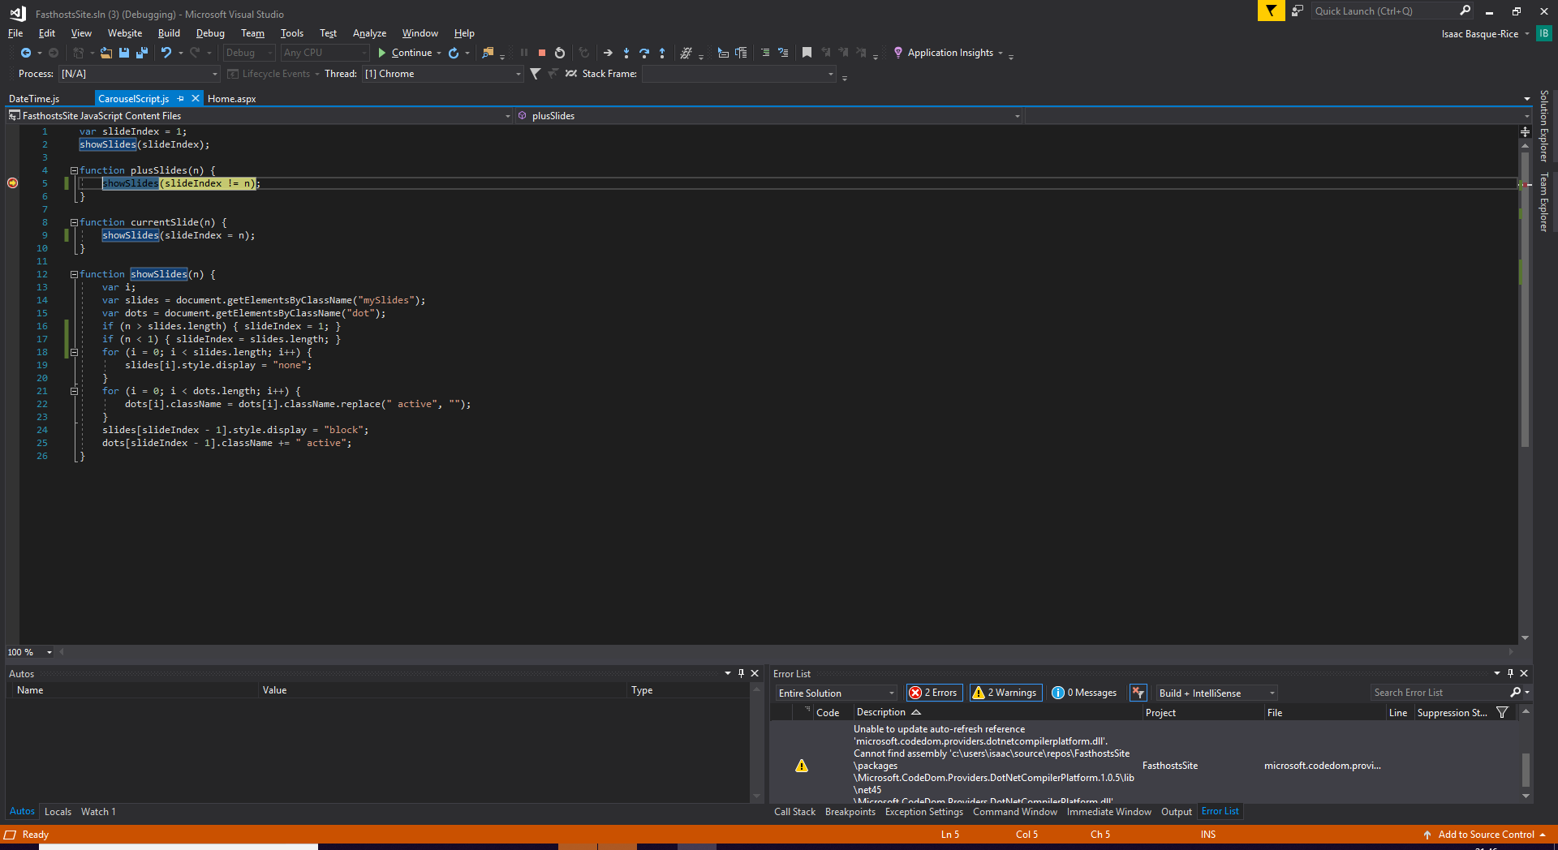

Screenshot 15

This was swiftly corrected and the carousel operated as normal.

The usage of a breakpoint in this solution was imperative, as I was able to recognise an error in code without having to comb through possibly hundreds of lines of code, additionally, the ability to step in, step over, and step out of specific points in code is also important, as it allows a developer to be made aware of all of the workings of the code within the test environment, values held in memory, general purpose registers, files, etc. As such a developer can be made aware of issues and change code accordingly.

## Search Page

At this point I have a total of 16 possible TLDs within my TLD database, for which I have built a search function

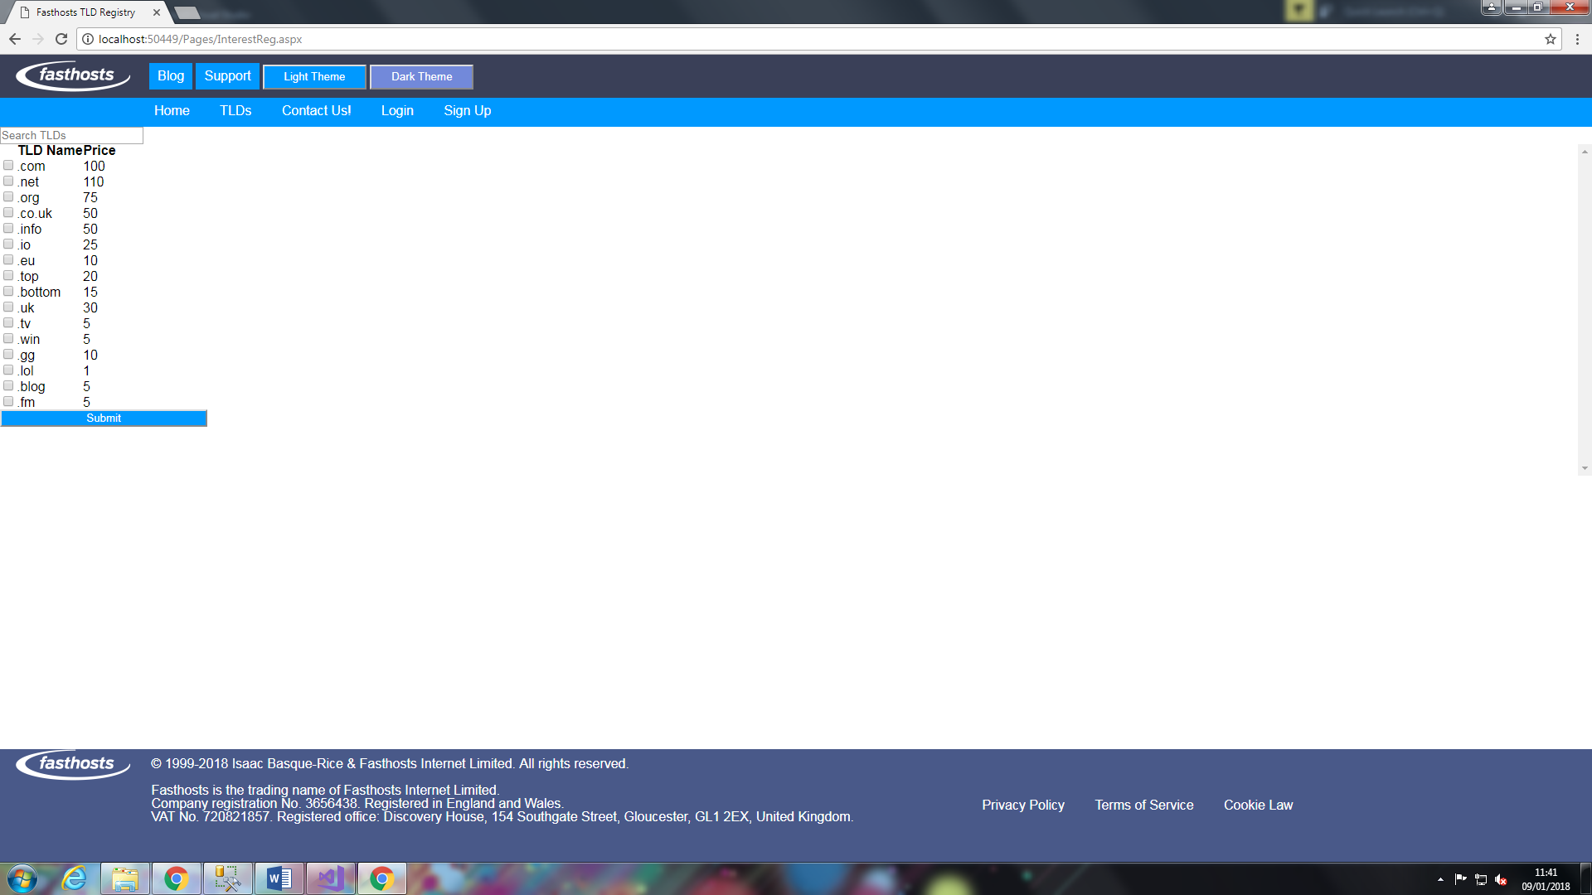

Screenshot 16

The TLD search page pulls data from the database and displays it for the user, with a checkbox next to it in order to facilitate interest registration. This may additionally fulfil the dynamic content requirement in the specification, as searching within the database for a specific key term may return entirely different results dependant on user input.

It is important at this time that we define ‘Dynamic Content’ in a website-specific context. In the earliest days of the internet, websites were almost entirely presented as static, unchanging pages, like a book, unchanged except by human intervention. However dynamic content changes based off of a user, for example social networks like Facebook, Reddit, YouTube, Instagram, and Twitter, are often powered almost exclusively by dynamic content, showing you specific content based on friends, subscriptions, previously watched videos etc.

An additional form of dynamic content, and the one on display in this instance, is a search function, that, when a user types in the name of a TLD, suggestions pop up. For example, if a user types in “.i” only TLDs beginning with I, such as .info and .io, will be displayed.

Below is a copy of a code snippet that powers this search function:

foreach (GridViewRow row in GridView1.Rows)

{

//sets a CheckBox to have the name selRow and searches row 0 in the SQL database (the TLDID row) for something with the specified ID perameter, "interestSelect"

CheckBox selRow = (row.Cells[0].FindControl("interestSelect") as CheckBox);

if (selRow.Checked)

{

//sets the string variable tldName to be equal to the text in a specified data field in row 1

string tldName = row.Cells[1].Text;

//defines and opens connection string to database

using (SqlConnection cn = new SqlConnection(ConfigurationManager.ConnectionStrings["FasthostsTLDShopConnectionString"].ConnectionString))

{

cn.Open();

//declares a sql command, to select a TLDID from the table TLD where TLD name has what the user has typed in in any position

using (SqlCommand cmd = new SqlCommand("SELECT TLDID FROM TLD WHERE TLDName LIKE '%' + @TldName + '%'", cn))

{

cmd.Parameters.AddWithValue("@TldName", tldName);

cmd.Connection = cn;

selectedTlds.Add(cmd.ExecuteScalar().ToString());

}

}

}

}

## Registration Page

The registration page is the page that I will be using in order for users to register with my site, data inputted into the registration form on this page will be submitted to the database, and each user given a single, unique user ID number

In order to be able to add data to the registration page it is necessary to, in the .net framework, apply C#

### Design

For this section of my solution I decided it would be best to build in design view as it is more efficient and gives a greater idea of the final page whilst you are in development.

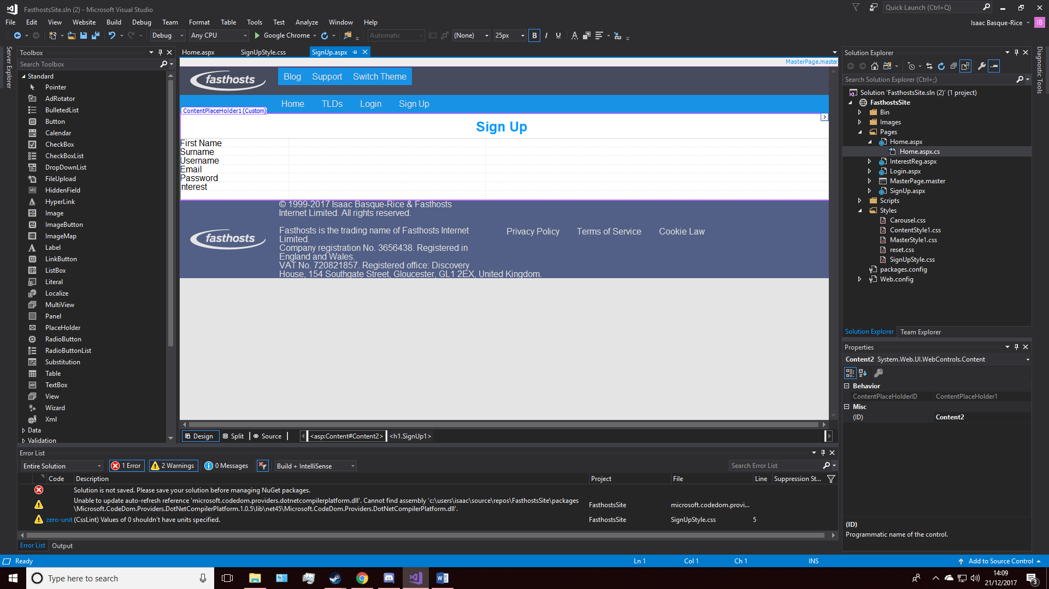

Screenshot 17

Above is a screenshot of my form as it was on 21/12/2017 at 14:10, as you can see I had inserted a 3*6 table in order to hold the majority of my content with regards solely to the form. My intent beyond this point is to add text boxes next to each of the pieces of text within each row, and next to them place regular expression validators linked to the text boxes, finally at the bottom I intend to include two buttons, a clear button, which will clear the form, and a submit button, which will submit the form to the database table. There are two anomalous rows as far as validation goes in this section, the Email field, firstly, requires a regular expression validator in order to validate the existence of an @ symbol within the text box. The interest field, being the second one, will have no validation, this is due to the fact that it is not a required field.

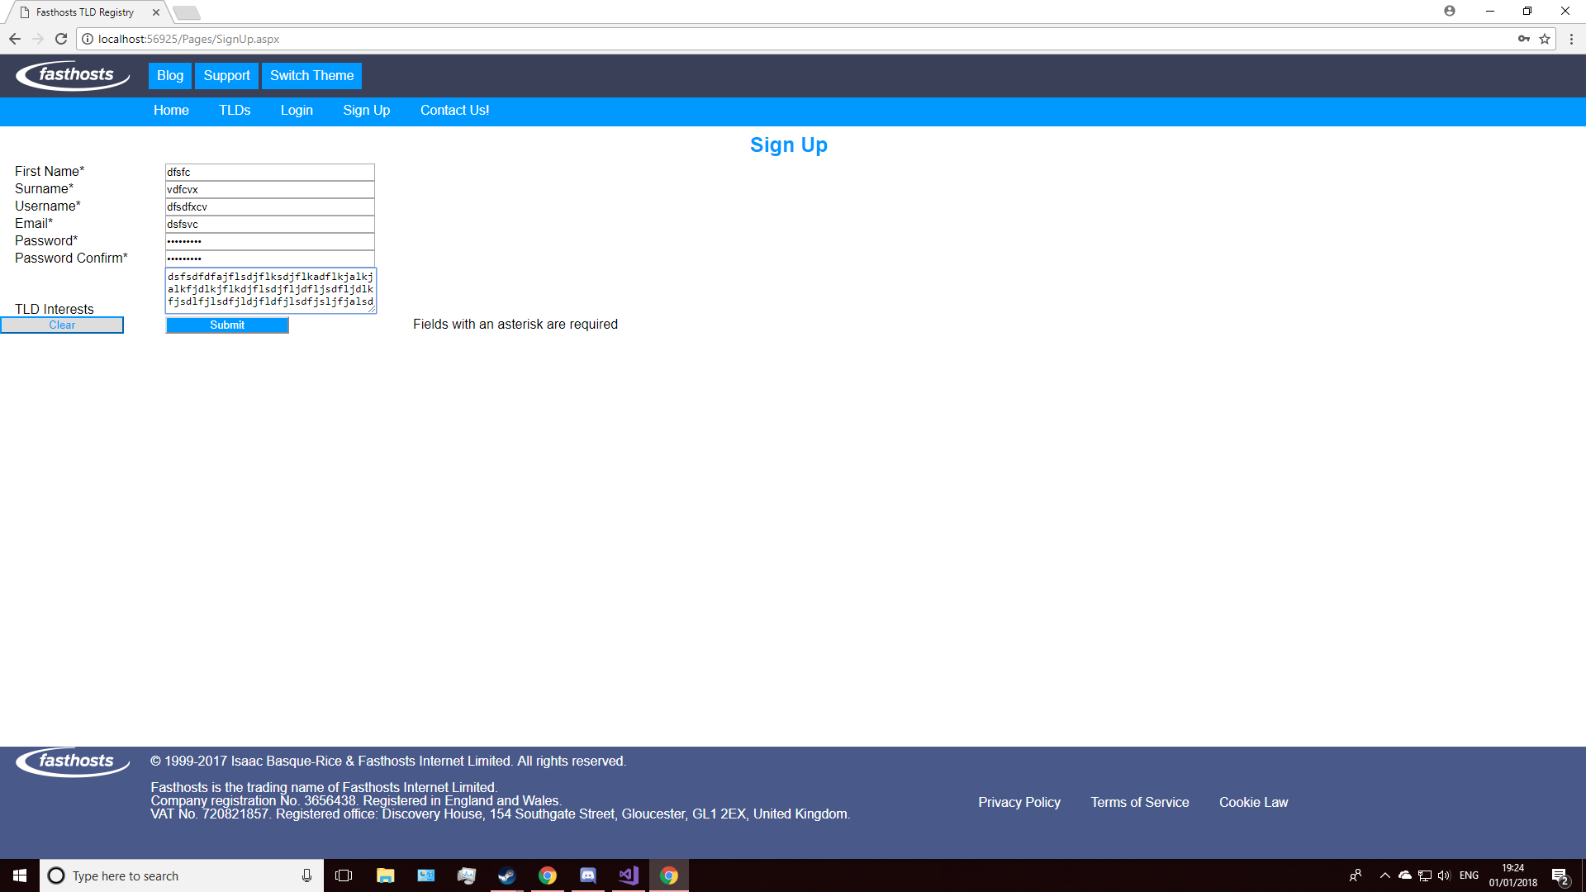

Screenshot 18

The above screenshot is of the (almost) completed sign up page, it shows first name, surname, username, email, password, password confirmation, and TLD interest text boxes, notice the last three, with the password boxes having dots as opposed to standard Unicode characters, and the TLD interest box containing the ability for users to write on multiple lines.

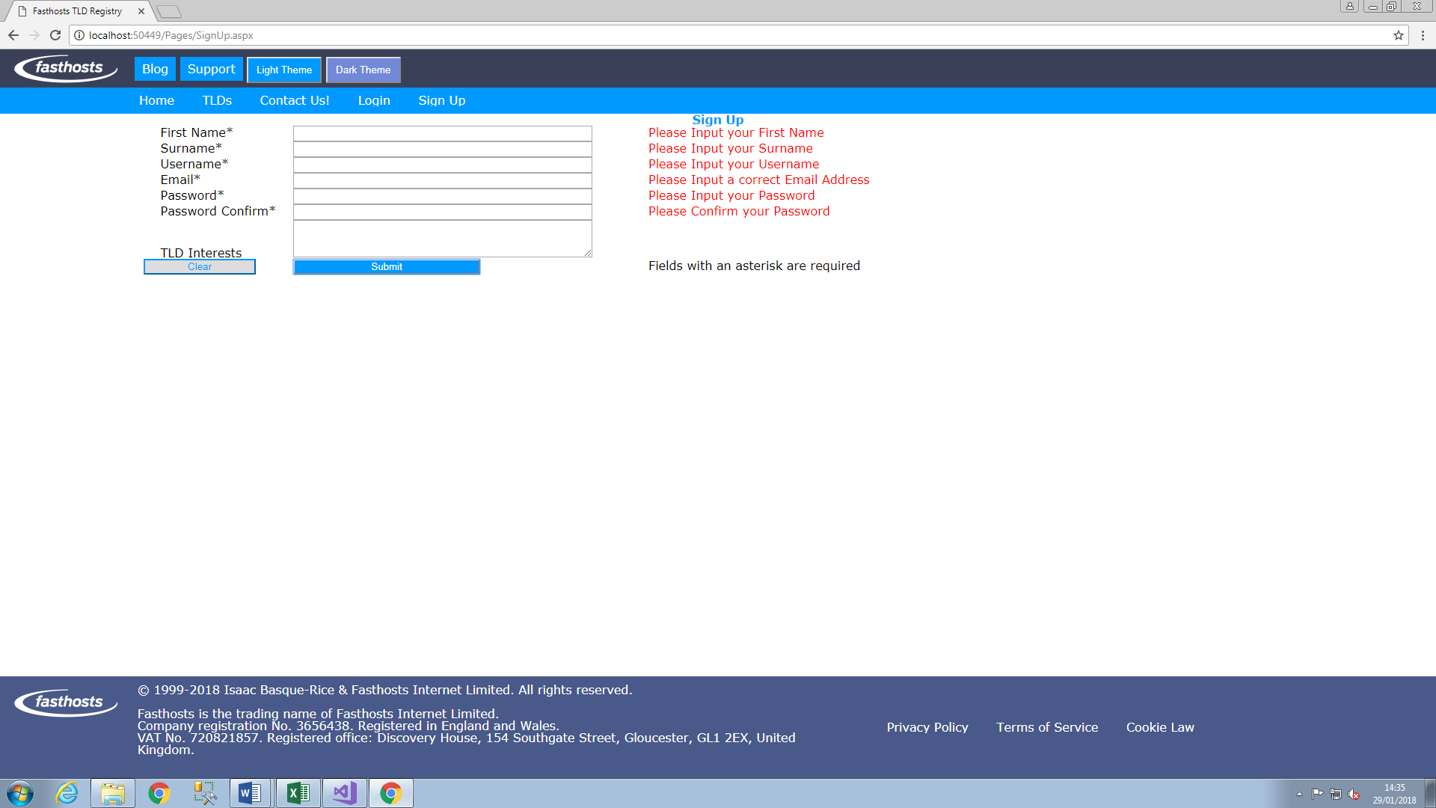

Screenshot 19

Above is an example of server-side (ASP.net) Validation. Each box first checks for any content, whether it actually contains anything, next the validation method checks to see if it meets requirements for that field, for example if an email has an @ symbol, or if a password has an upper and lower-case letter and a number, if at any point the criteria for each individual text field is not met fully then an error message appears in red next to the text field, as shown above.

The following is an example of ASP.net code that validates the first name box

<!-- ControlToValidate tells the website what specifically is being validated (the text box in this case) -->

<asp:RequiredFieldValidator ID="rfv_FirstName" runat="server" ErrorMessage="Please Input your First Name" ForeColor="Red" ControlToValidate="tb_FirstName"></asp:RequiredFieldValidator>

Certain forms of validation, such as email validation, requires what is known as a ‘Regular Expression Validator”, or RegEx Validator, for email’s case, it looks like this:  
"\w+([-+.']\w+)*@\w+([-.]\w+)*\.\w+([-.]\w+)*"

This essentially just checks for the presence of at least 1 full stop and an @ symbol in everything that is put into the email field, if it does not contain these specific characters at any point then an error message is returned.

### Stylings

Due to the nature of ASP.Net’s design view, stylings, wherever necessary, are applied by assigning a class to the necessary section of the solution, the class being “AutoStyleX” where X represents the number autostyle it is (AutoStyle1 being the first, AutoStyle4 being the fourth, etc.). This class is referred to in the header of the HTML document, known as **inline**, as opposed to being in a separate Style Sheet document. Both inline CSS and AutoStylings are generally considered to be bad practice, and so therefore in the HTML document I will be renaming the relevant classes and placing the stylings into their own separate document.

### Server side code

The server side code is imperative to the functionality of this page, specifically allowing users to input data into the database, linking text boxes to specific SQL server columns, and importantly, referencing locations within the database for data to be inputted into.

protected void btn_Submit_Clicked(object sender, EventArgs e)

{

//declares variables and sets them equal to the value of their respecive text boxes

string username = tb_Username.Text;

string firstName = tb_FirstName.Text;

string surname = tb_Surname.Text;

string email = tb_Email.Text;

string password = tb_PWord.Text;

//opens connection string to FasthostsTLDShop

SqlConnection cn = new SqlConnection(ConfigurationManager.ConnectionStrings["FasthostsTLDShopConnectionString"].ConnectionString);

cn.Open();

//declares a SQL command that inserts a data field into the User table

SqlCommand cmd = new SqlCommand("INSERT INTO [User] (FirstName, Surname, Username, Email, Password) VALUES (@firstname, @surname, @username, @email, @password)", cn);

cmd.Parameters.Add(new SqlParameter("@firstname", firstName));

cmd.Parameters.Add(new SqlParameter("@surname", surname));

cmd.Parameters.Add(new SqlParameter("@username", username));

cmd.Parameters.Add(new SqlParameter("@email", email));

cmd.Parameters.Add(new SqlParameter("@password", password));

//a try catch method that redirects the user to the homepage if the input is successful and returns an error message if not

try

{

cmd.ExecuteNonQuery();

cn.Close();

Response.Redirect("~/Pages/Home.aspx?src=");

}

catch (Exception b)

{

Response.Write("Couldn't add the user to the databse");

}

}

The code above firstly creates variables, linking them to existing text boxes within the solution, and naming them roughly in line with the corresponding text boxes names. Next it opens a connection string to the SQL database created for this solution, linking the text box variables to columns in the front end of the site, and as such allowing for users to input data into said table. The final section of code redirects a user to the homepage upon successful account creation, in the event of unsuccessful account creation it alert the user with the error message ‘couldn’t add the user to the

### Issues

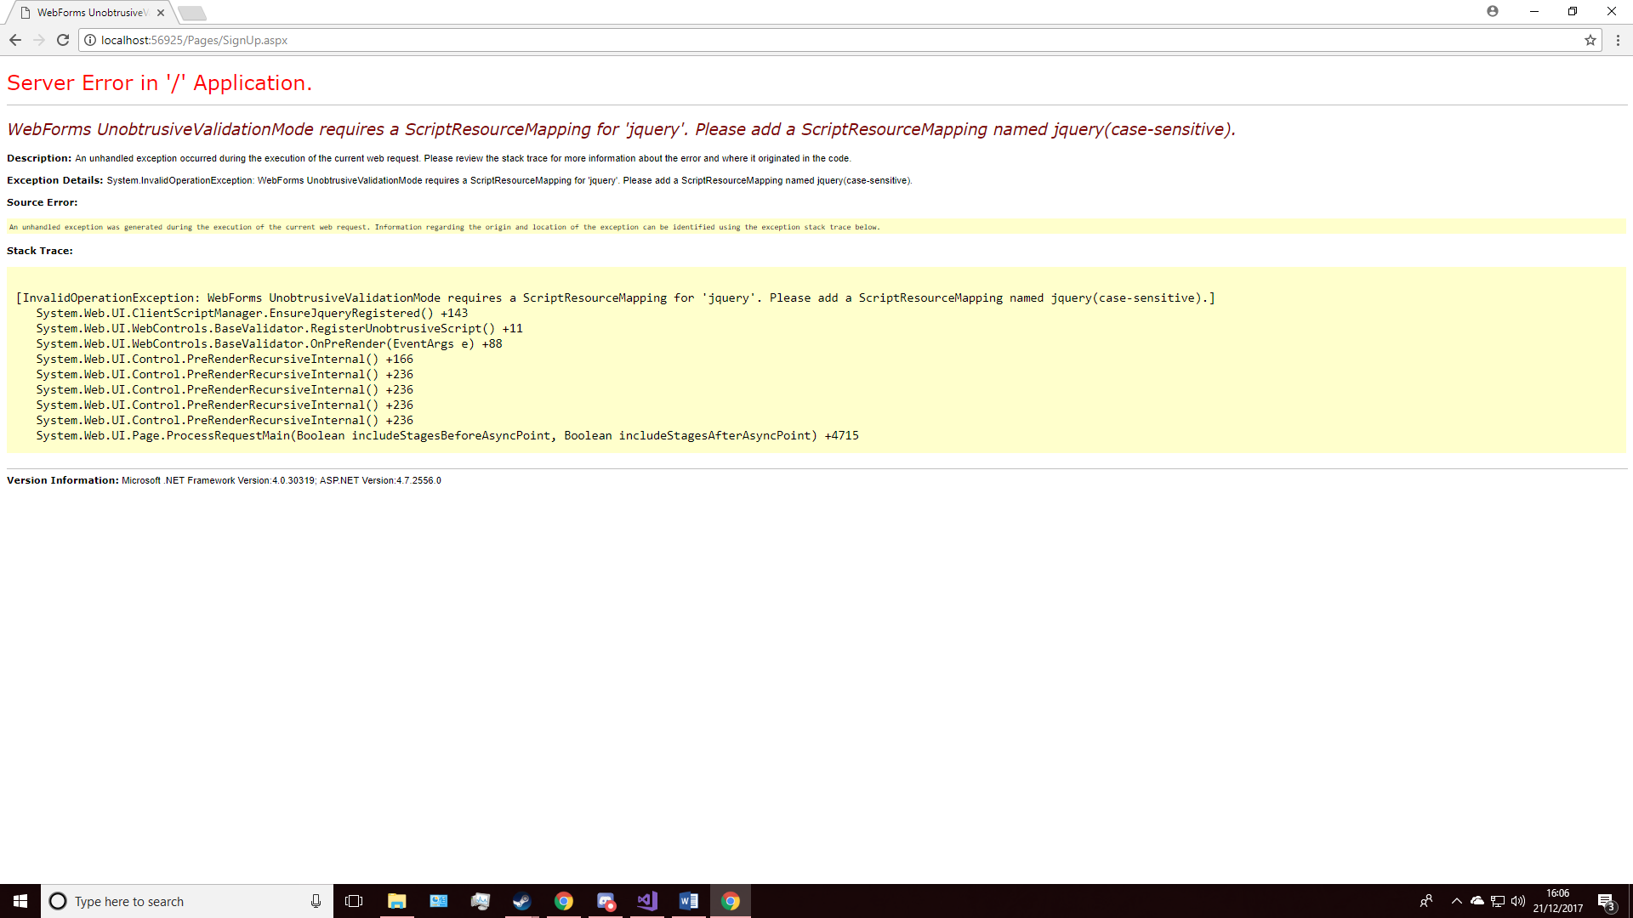

Issue Screenshot 7

The first issue came after I had added validation to my text boxes, the error “WebForms UnobtrusiveValidationMode requires a ScriptResourceMapping for 'jquery'. Please add a ScriptResourceMapping named jquery(case-sensitive).”

The fix for this was adding the following lines of code to my web.config file:

<appSettings>

<add key="ValidationSettings:UnobtrusiveValidationMode" value="None" />

</appSettings>

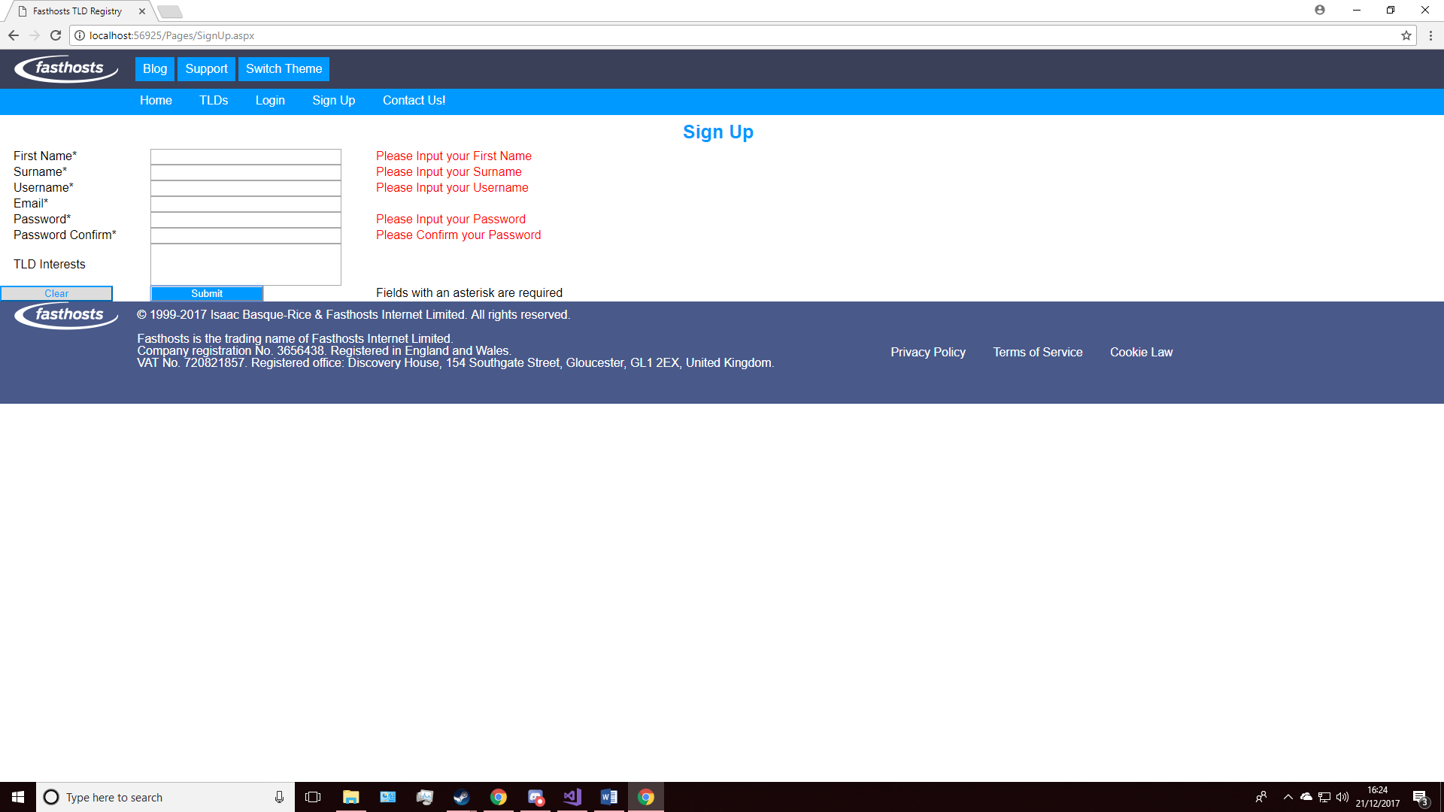

Issue Screenshot 8

## Login Page

The login page is the most deceptively complex page within the solution, upon first glance it may seem to just be two boxes, username/email and password, however behind the scenes, as it were, the login page is responsible for several tasks that one may not consider at first.

For example, the form’s ability to access the SQL database in which the website’s user data is stored is key to the function of the website. In addition to this, this data, once checked and validated, must be displayed somehow within the master page (like Amazon’s “Hello, [firstname]” feature that they have in the top left corner of their site once a user is logged in

### Content

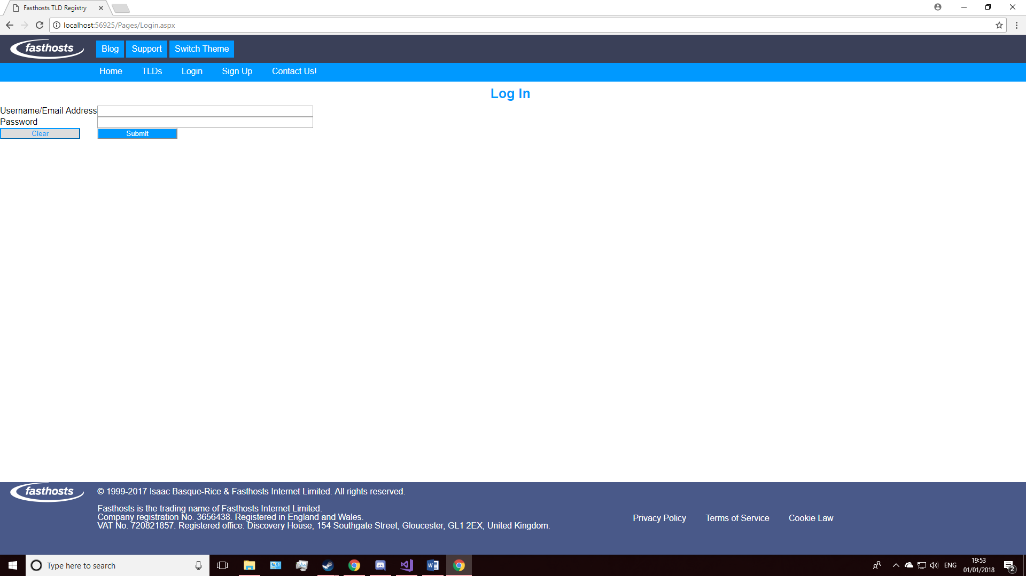

Screenshot 20

This is the (mostly) completed frontend of the login page, it is noticeably simpler than the sign-in page, and however it takes its design from it, including the width of the boxes and the buttons below.

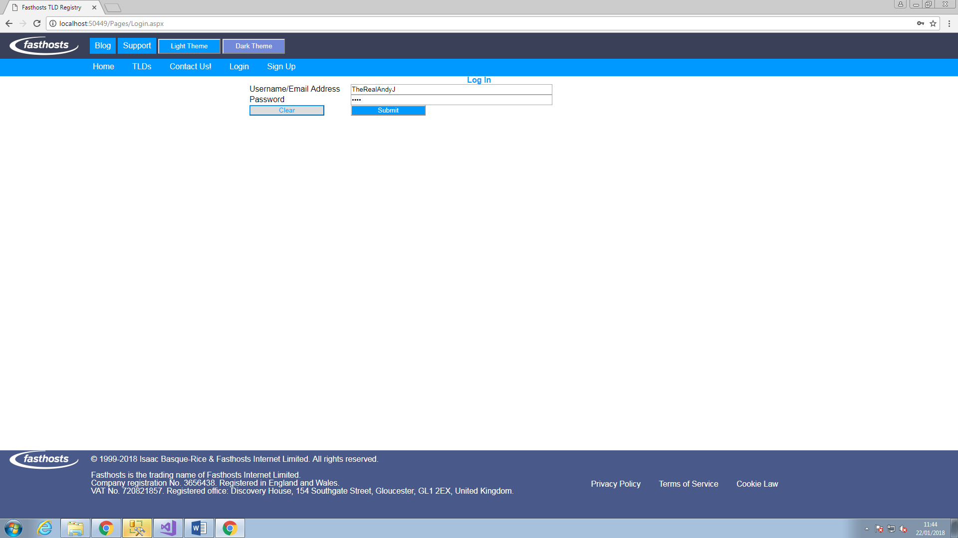

Screenshot 21

A screenshot of a filled out form (above).

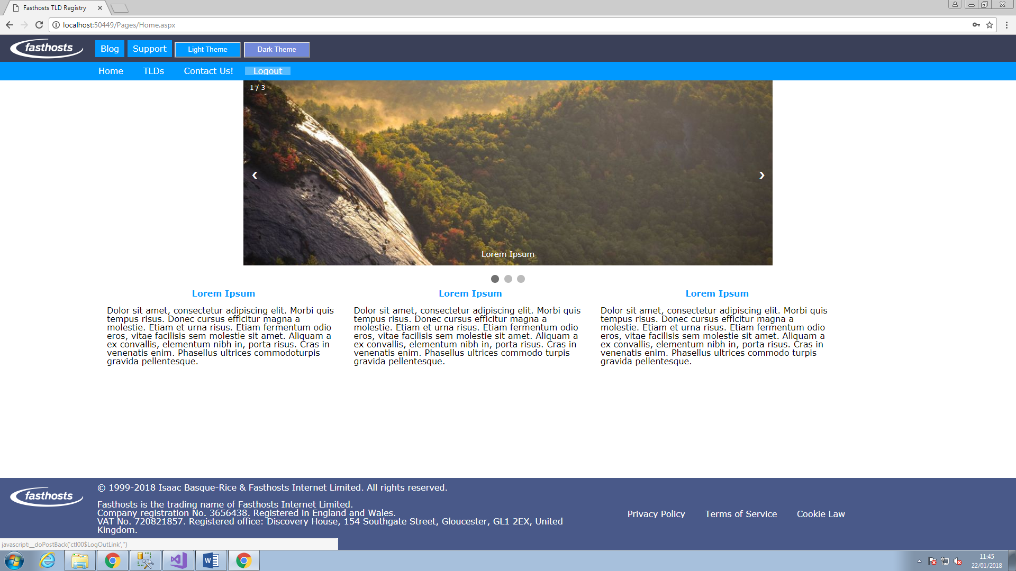

A screenshot of the site once logged in, notice the addition of the highlighted hyperlink ‘logout’ and the removal of the ‘Sign up’ and ‘Log in’ links.

protected void btn_Submit_Click(object sender, EventArgs e)

{

using (SqlConnection cn = new SqlConnection(ConfigurationManager.ConnectionStrings["FasthostsTLDShopConnectionString"].ConnectionString))

{

if (rfv_li_UserName.IsValid && rfv_li_PWord.IsValid)

{ //conection open

cn.Open();

string Sel = "SELECT * FROM [User] WHERE Username = @Username AND Password = @Password";

SqlCommand Cmd = new SqlCommand(Sel, cn);

Cmd.Parameters.AddWithValue("@Username", tb_li_UserName.Text.Trim());

Cmd.Parameters.AddWithValue("@Password", tb_li_PWord.Text.Trim());

int i = Convert.ToInt32(Cmd.ExecuteScalar());

if (i >= 1)

{

SqlDataReader read = Cmd.ExecuteReader();

while (read.Read())

{

//the getstring / getint32 statements relate to the column in the SQL database, (arrays start at 0), then once logged in it redirects

Session["User"] = read.GetString(3);

Session["LoggedInUserID"] = read.GetInt32(0);

Session["UserRealName"] = read.GetString(1) + " " + read.GetString(2);

Session["LoggedIn"] = true;

Response.Redirect("Home.aspx");

}

}

else

{

Response.Write("Username/Password is incorrect");

}

}

}

}

The code above is the server side code that allows the user to input their previously committed (to the database) data, namely username and password, and be allowed access to the site without issue, in short it is the code behind that allows the functioning of the login page.

In addition to this, I have created a class to hold the information of logged in users that I may intend on using to display the ‘Hello [FirstName] notification, code for this is as follows:

/// <summary>

/// A class to hold information about logged in users

/// </summary>

public class User

{

public string UserName { get; set; }

public string FirstName { get; set; }

public string Surname { get; set; }

public int UserID { get; set; }

}

## Contact Form

The contact form, within this solution, serves to fulfil the requirement that in at least one section of the website I utilise JavaScript validation, as such I have built a HTML form from scratch, as opposed to using the visual editor and utilising asp.net functionality

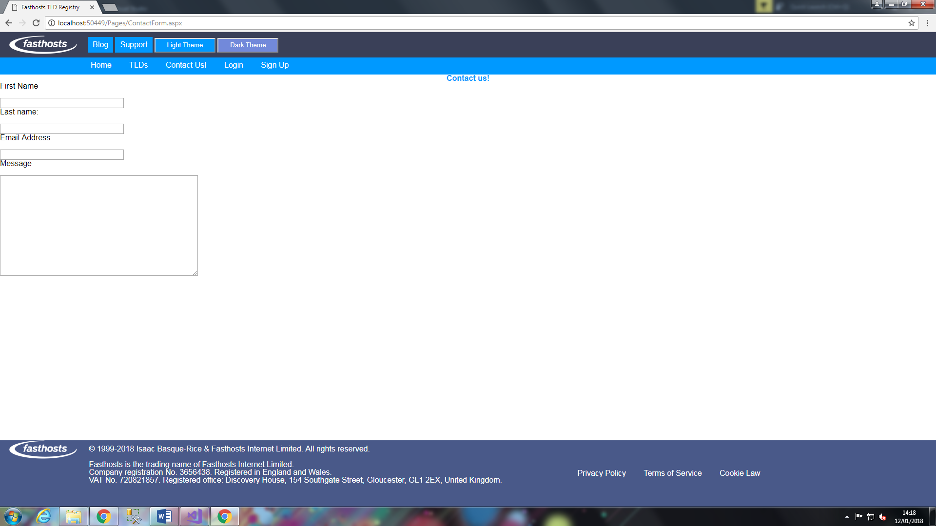

Screenshot 22

The screenshot above demonstrates this, four text boxes, first name, surname, email address, and message, which is used to send us feedback about the website, this should eventually be stored within a database, which I am yet to create. The next step of this would be adding the previously mentioned JS validation and a submit button.

### HTML Forms

HTML forms serve as the primary method of data collection within my solution, serving as a method of front-end data input and user interaction with the relevant SQL server. For example, the registration page serves to input user data, such as first and surname, as well as email and password, into the database.

HTML forms (as opposed to ASP.net forms) do not utilise server-side processing, instead opting, for its validation system, to use JavaScript, a client-side scripting language. As a result of this, load times tend to be faster with HTML forms as opposed to ASPX forms, however ASP has a significantly larger degree of customisability.

In modern internet-based companies, data collection is everything. It allows the organisation to better understand their users, as well as be able to appeal to them directly through email, telephone, or other ways entirely.

Methods of data collection within a website solution are numerous, the most obvious of these being, as the title of this subheading suggests, web based forms. However this is not the only method of user data collection, others include cookies, HTTP logging, and a large collection of others

Cookies, firstly, are text files that contain a unique user ID and site name, this allows businesses to track a user’s browsing habits and tailor advertising especially for said users. Upon visiting a website with cookies, said cookie is installed onto your device and upon revisiting said website information from the cookies is fed back into the site. (WebWise , 2012)

HTTP logging, additionally, stores and records all transactions between a web server and a user, however this data does not tie to a specific user, making this form of data collection unhelpful for individual, “dynamic” tailoring, but excellent for an aggregated view of a whole user base. (MIT, 1998)

These two technologies, in tandem with each other, however, produce a powerful holistic data collection tool. As an example of this, these two technologies can determine ISP, country, browsing habits, most popular site aspects, most effective ads, and potential customer areas of interest (MIT (1), 1998)

From this data, we can see what countries our website is most popular in, tailor advertising (as mentioned previously), it can allow a shift in focus from one aspect of a website to another based off of popularity, and determine what customers, on an individual basis, would like to see in regards to their previous browsing habits. As an example, for the last point, take Amazon’s “Customers who bought this also liked…” feature, which, based off previous and/or current browsing patterns will suggest further products for a consumer to enjoy.

This collected data allows an organisation to do several crucially important things, it allows them to make better decisions through informing said organisation of users’ experience, web traffic, and websites they visit, most popular/least popular products, etc. and change business practices accordingly in order to serve their users. It also allows an organisation to see their performance in comparison to other, similar organisations, as well as this, it also helps businesses improve generally, and crucially, allows businesses to understand consumers and the market (Larsen, 2017). In my solution this is achieved primarily through the contact form, which allows users to give express feedback on the quality of their experience and improvements developers could make.

As far as opportunities available to HTML forms specifically go, explicit data collection tools such as these serve as express consent, in certain circumstances, to use the data an individual has willingly provided for a businesses’ own end.

### Content

A note: due to issues surrounding JavaScript validation’s compatibility with ASP.net web forms (detailed specifically in the ‘issues’ subsection of this section of the document), I have taken the decision to import the code from the master page into a separate HTML5 document and build the webform in there, this should not affect the overall look or performance of the page generally.

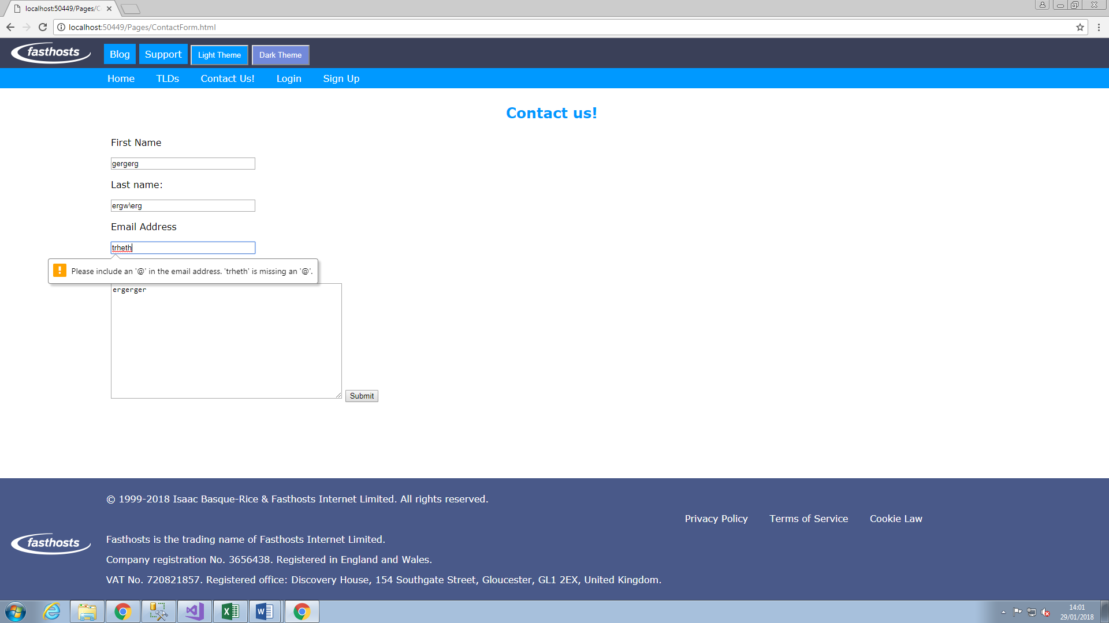

Screenshot 23

The above screenshot demonstrates JavaScript email validation, within the JavaScript exists a regular expression validator, intended to check for the presence, primarily, of the @ symbol, but also for symbols that are generally accepted to be allowed or disallowed based on the naming conventions for email addresses, such as allowing numbers 0-9, letters a - z, A - Z, and a select number of symbols (!#$%&'*+-/=?^_`{|}~),

### Issues

An issue noted in the Content subsection relates to JavaScript Validation’s incompatibility with ASP.net webforms, specifically, solutions to the task of implementing JS validation that I have found from external sources tend quite heavily towards requiring the form to be nested within a <form> tag, however, due to the nature of ASP.net webforms, and by virtue of content pages being offspring of the master page, which within it contains a form tag, and due to the fact form tags cannot be nested within form tags, I have decided to copy the master page into a separate HTML5 document and work from there. A seemingly obvious fix would to be to remove the form tag from the master page itself, however this seemed to have an adverse side effect on other pages, specifically the carousel on the homepage not showing images, so as not to affect other pages I have decided to use the method described here.

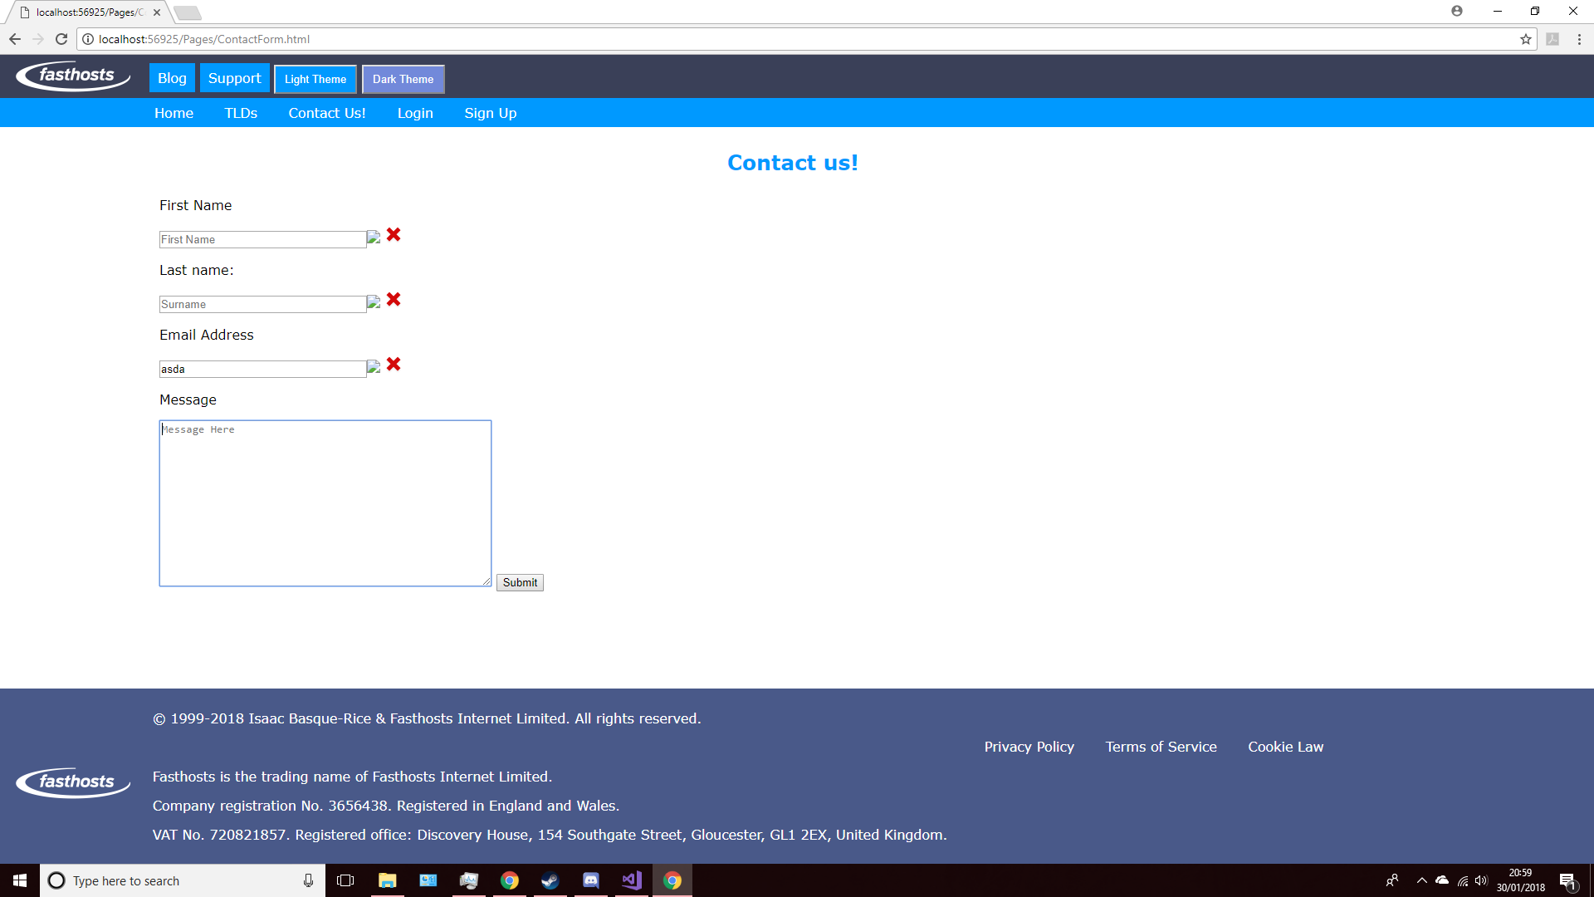

Issue Screenshot 9

Another issue can be seen here, on page load, red crosses are standard, and upon leaving the empty fields blank and submitting, an unassigned image marker appears next to the boxes

## Misc. Backend

This section is dedicated to miscellaneous backend tasks that may not necessarily fall under any other heading. Backend, within this solution, primarily comprises of database tasks.

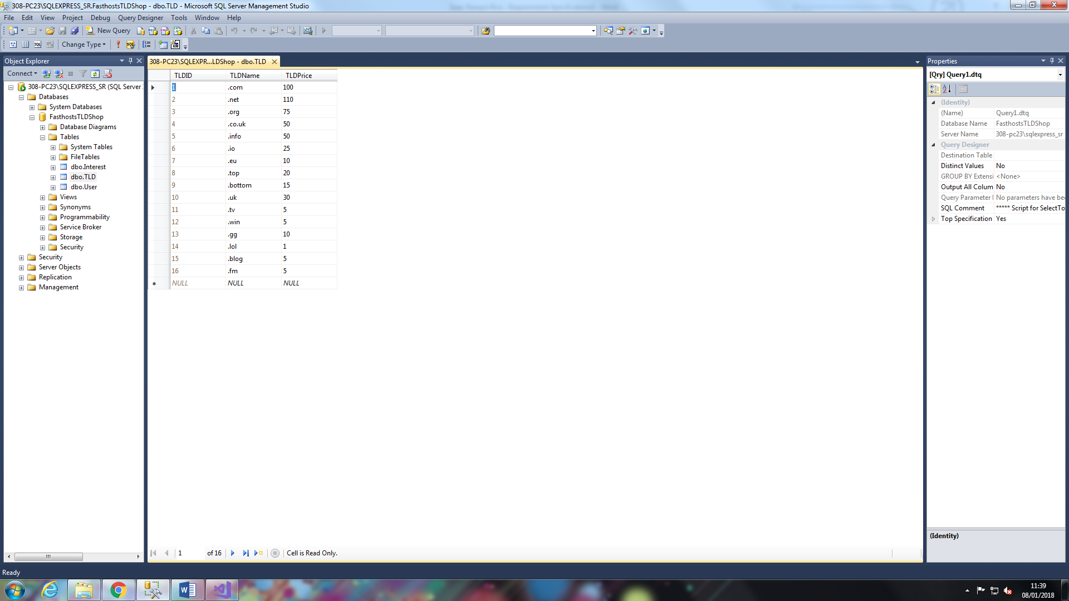

Screenshot 24

Above are a list of 16 top-level domains and prices associated with them, this database table will be used to power a search function that is to be implemented at a later date.

In addition to this, the function to register interest in TLDs for specific users has been implemented using C# methods to interact with the database’s interest table, as you can see in the screenshot below:

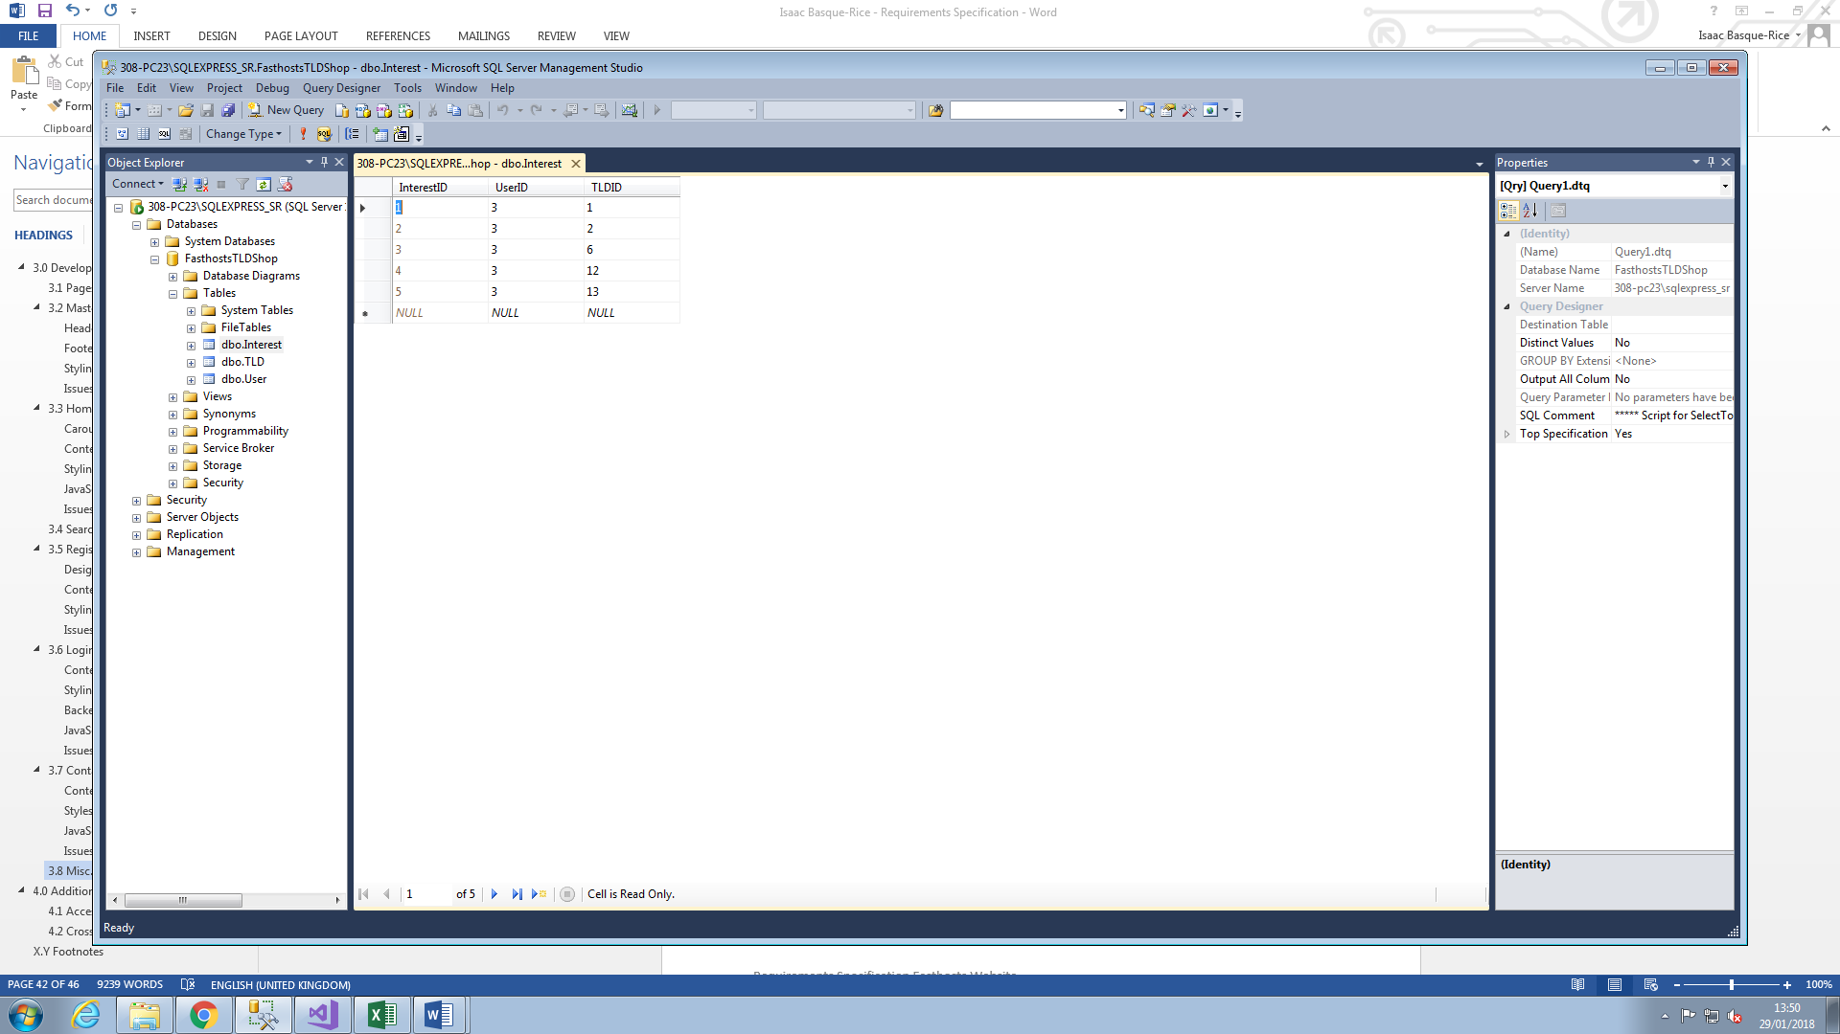

Screenshot 25

User 3 has registered interest in 5 separate TLDs, TLD 1, 2, 6, 12, and 13, respectively, this fulfils the requirement for a user to manipulate data within a database.

# Additional Requirements

This section is dedicated to any additional items and requirements that may be added once the core elements of the site have been implemented fully. In addition to added (and perhaps slightly unnecessary) items, this section will cover accessibility, be it for those who have a disability such as blindness or colour blindness, or to comply with W3C standards, which can be checked by a code validation software found on their website.

Additionally, As much as I am required to build the website itself, hosting is another thing entirely. If I were to host the website, I would most likely do so on <https://host.gwiddlefoundation.org.uk/>, which is a hosting service that allows for free hosting for students provided they give verifiable information that they are, indeed, students

## Themes and usability

A dark theme has several benefits that cause them to be preferred by some to the “standard”, or light theme, the one as mentioned previously, dark themes may provide a better user experience for colour blind people than a light theme, but also some non-colour-blind people prefer dark theme as with 92% of developers preferring a dark-themed IDE to one with a light theme. The reason for this is relatively simple, it reduces unwanted eye strain on the user and provides a more relaxing, usable experience than being bombarded with bright light constantly.

Additionally, Flicker problems are less noticeable, colours (when used to convey information, syntax highlighting) is able to be more easily noticed in front of a dark background, dark backgrounds may save electricity on certain devices, and faulty/dead pixels may be less noticeable, however a light theme may also be superior in certain regards, visually impaired individuals may find a lighter theme to be more usable, and studies have shown that black text on a white background is 26% easier to read than the reverse. As such the only conclusion one could come to is that a theme switching device is useful in many regards.

|  |  |  |
| --- | --- | --- |
| Colour | Hex Code | Use |
|  | #23272a | The darker of the two dark greys, used for the header and footer |
|  | #2c2f33 | The lighter of the two dark greys, used for background, contrasts nicely with the other grey and complements the purple |
|  | #7289da | Used for the nav bar |
|  | #43474e | Used primarily for the a:hover element |

The colours for the dark theme are inspired heavily off the popular VoIP application (primarily used for gaming) known as Discord, and in order for the user to be able to switch styles I have decided to implement a third-party JavaScript library.

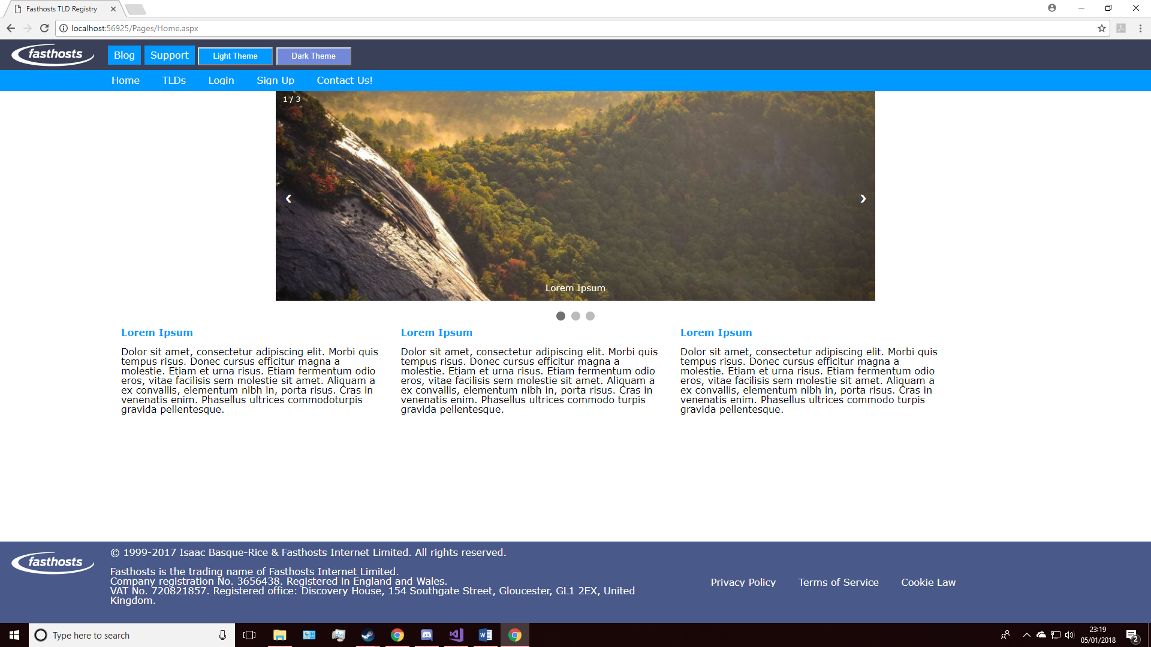

Screenshot 26

This screenshot includes two buttons at the top, a dark and light theme button, my aim is to get the dark theme button to, through the use of jQuery, be able to switch from the light theme to the dark theme, and vice-versa for the other.

In order to be assured of my success, I have taken the decision to create a secondary website in order to test the ability to switch themes

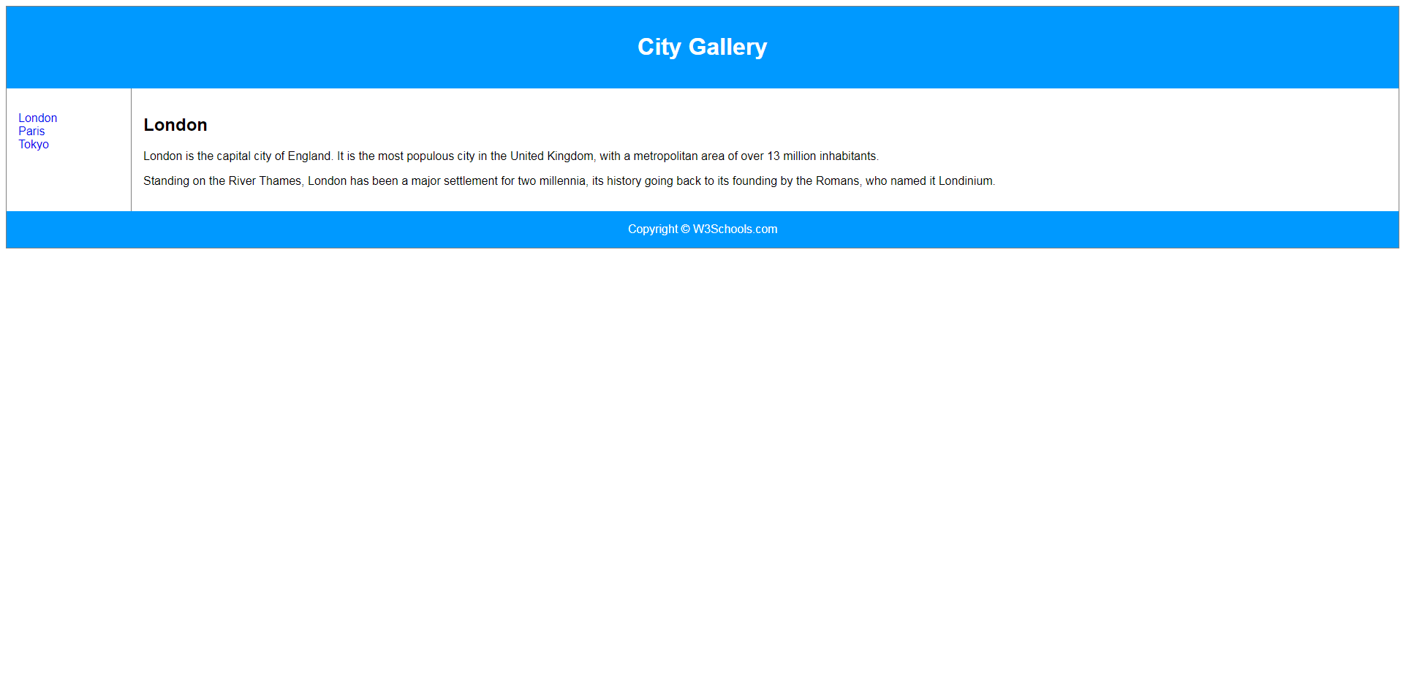

Screenshot 27

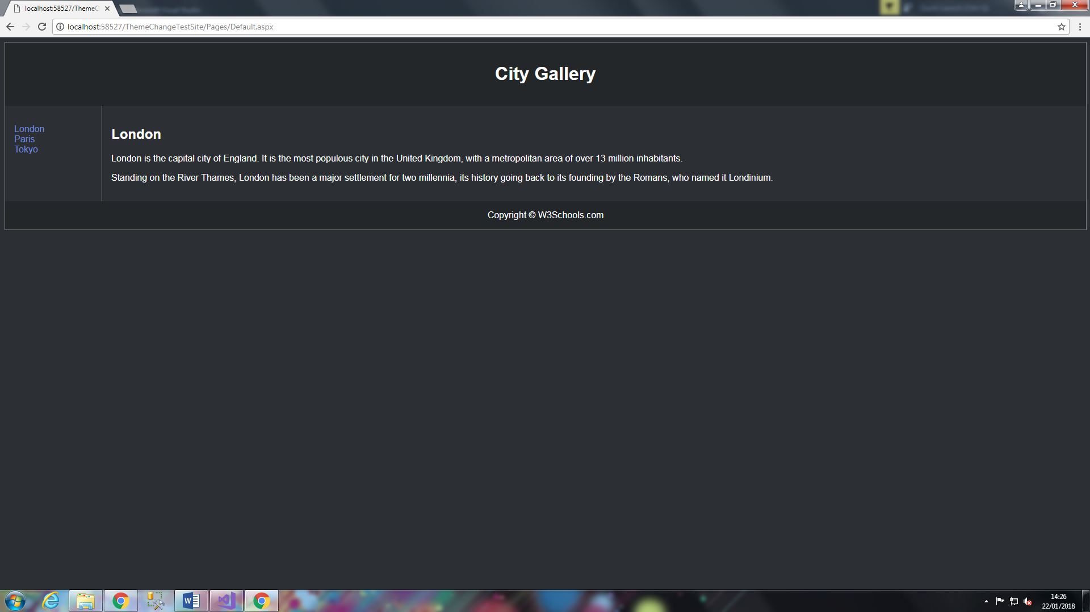

Screenshot 28

The first screenshot here (screenshot 27 - above) is of the Light theme, notably, the dark theme has not been included in the header so there is no way of switching even if both themes were present.

Both of these screenshots are of the website I have created in order to test theme switching, unfortunately, as the second screenshot demonstrates, the site instantly loads into the dark theme despite the head containing both dark and light themes, as a result of this I must look into other methods of theme switching to fulfil this criteria.

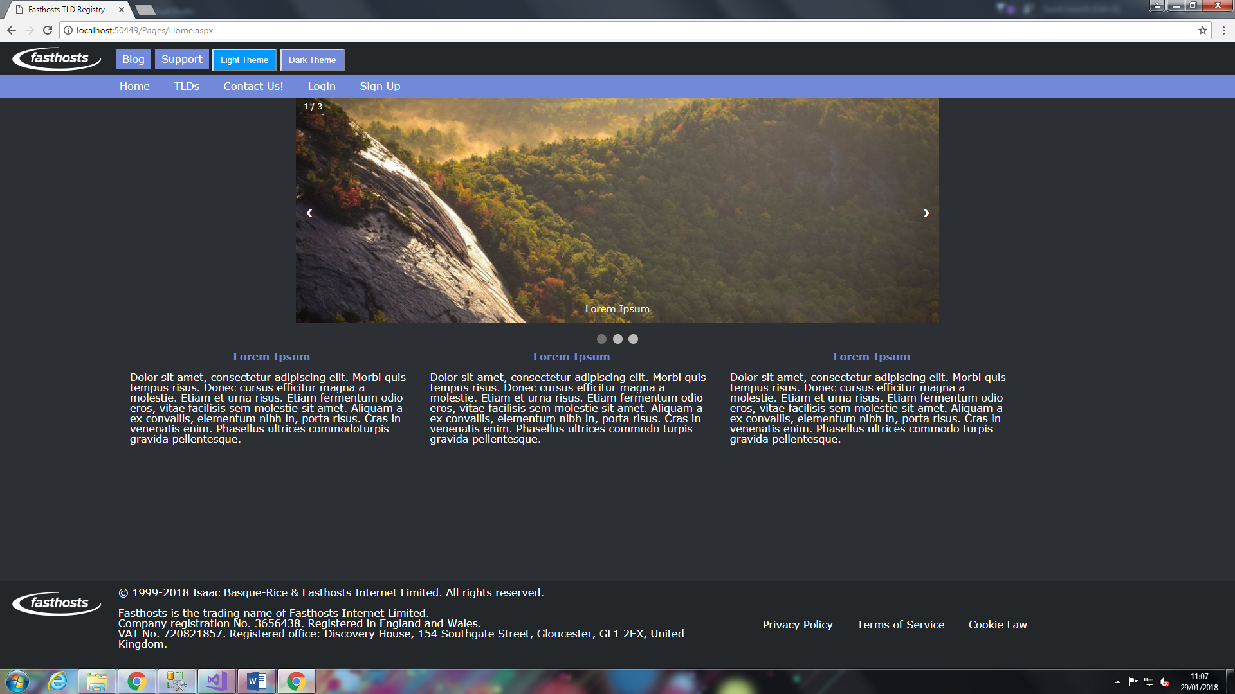

Screenshot 29

The screenshot above shows the dark theme in use on the website, ultimately, I have elected NOT to use jQuery, instead opting for a server-side solution, with code as seen below:

protected void Page_Load(object sender, EventArgs e)

{

//theme switching

if (Session["theme"] == null)

{

Session["theme"] = "light";

}

if (Session["theme"].ToString() == "light")

{

theme.Attributes.Remove("href");

theme.Attributes.Add("href", "../Styles/LightTheme.css");

}

if (Session["theme"].ToString() == "dark")

{

theme.Attributes.Remove("href");

theme.Attributes.Add("href", "../Styles/DarkTheme.css");

}

}

The use of session tokens allow the website to “remember” the status of the website as having a dark or light theme, and as a result allow you to load other pages directly into the dark theme as opposed to loading into the light theme and having to switch to dark manually on each page of the site you visit, this also fulfils the requirement of a bespoke server-side scripted class.

## Accessibility

Accessibility is a feature that I am not only morally, but legally obliged to embed into my solution, the Disability Discrimination Act (henceforth referred to as the DDA) of 1995 requires me as a web developer (and also any and all service providers, regardless of sector) to make so-called ‘reasonable adjustments’ in order to cater for those with disabilities of any kind.

In my instance, given that websites are a mainly visual medium, the DDA mainly (but not entirely) covers those with visual impairments such as partial to full blindness and colour blindness, both of which are dealt with, within the context of a website, in different ways entirely.

Firstly, blindness is arguably the simpler one, as the majority of practices that comply with the DDA in this instance are also basic and best practices of web developers anyway. For example, those who are fully blind or close to being so may use a screen reader, which prioritizes heading tags over paragraph tags <h1> <h2> etc. over <p>). As such, heading tags are important in this instance.

In addition to this, there is no way for a piece of screen reading software to interpret an image, as such parses it as blank space and moves on to the remaining text. In a large percentage of instances this is not an ideal situation, as such, an ‘img alt’ attribute must be appended within a href tag for an image, as so:

<img src="smiley.gif" alt="Smiley face">

In this instance, the img alt attribute, equal to “Smiley Face”, allows the screen reader to interpret the message of the image somewhat, as text is hidden behind the image in question. (Lawton-Henry, et al., n.d.)

In addition to those who are almost/totally blind, those who are otherwise visually impaired may benefit from the use of other techniques, such as those outlined by the British Government:

Use only clear, commonly used fonts. Avoid the use of small text. Users should have the ability to scale fonts.

Addressing the three sections to that recommendation individually: Clear, commonly used fonts such as Arial, Helvetica, or any other sans-serif fonts, should yield improvements in usability for those who have learning impairments such as Dyslexia. The usage of overly small font is to be avoided for obvious reasons, visually impaired people may not be able to see smaller fonts, and finally, the ability to scale fonts is inbuilt into most, if not all modern browsers by using Ctrl + Mouse wheel.

Colour Blind people, however, are an entirely different animal, as it were. The ability to differentiate between colours may be imperative on any given website, as such I (and Fasthosts themselves) feel it necessary to add a second, more inclusive style to the website.

I have determined that the appropriate theme to adopt would be a ‘dark theme’, a theme which uses mostly black, some white, and various shades of grey (see: Discord, Visual Studio, etc.). The reason I have deemed this theme most appropriate is as following: firstly, in order to cater for any issue that may arise from having a colour-blind user, and secondly, as not to inhibit a non-colour-blind user. Indeed, in some cases, non-colour-blind users prefer a dark theme from a standard theme.

Additional accessibility recommendations set by the W3C include a lack of necessity for mouse input on a website, instead allowing all users, if they so need, to make use of the keyboard for navigation. This is in order for those with a lack of fine motor skills, such as the elderly, to be able to make full use of the web and not be required to use a mouse (Lawton-Henry, et al., n.d.),. As well as this, an ability to turn off any flickering light on screen is required, ideally flickering light would be reduced to begin with but if this is not possible then controlling flickering works fine, this is due to flickering light disturbing those with photo-sensitive epilepsy, potentially inducing a seizure in most sufferers (Chisholm, et al., 1999).



## Cross-Browser Differences

Across the several different browsers used frequently (Chrome, IE, Firefox, Safari, and to a lesser extent, Opera), each and every browser comes with a different set of internal, basic CSS styles which apply in the event of a lack of an overriding stylesheet or file within your solution, chrome would have different base padding, font style, borders, margins etc. than IE or Firefox, for example. In order to overcome this, one may implement a CSS reset file, which causes every instance of the site, when rendered, to use the exact same set of base rules.

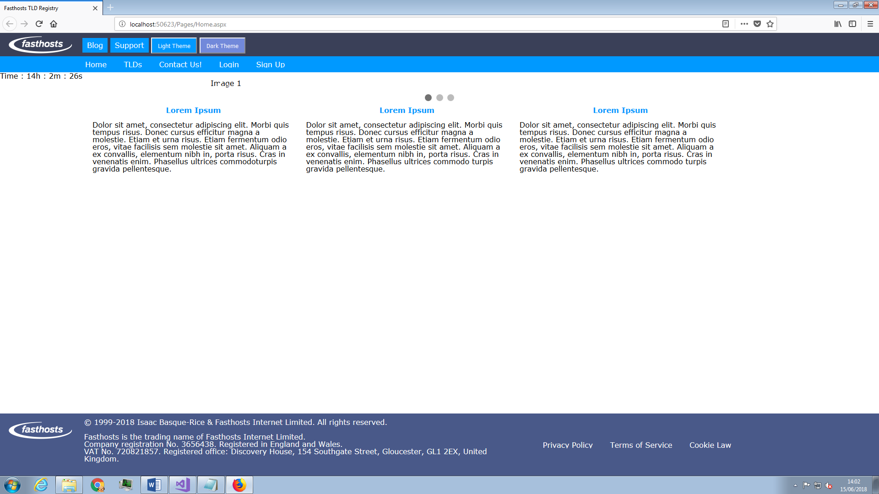

Screenshot 30

A cross-browser issue that has appeared on Firefox that has not occurred on IE or Chrome is the fact that images on the carousel have not appeared, this can be fixed by a reset.css file, as shown in the screenshot below:

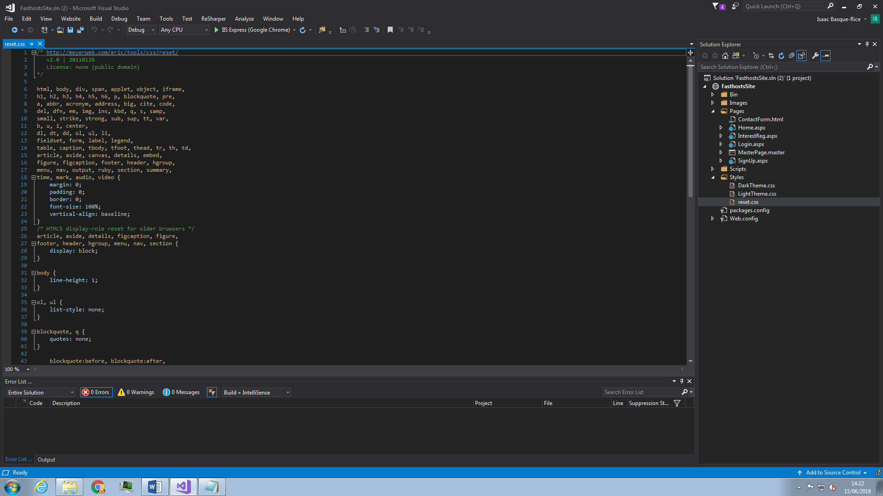

Screenshot 31

Additionally, a cross-browser CSS difference has appeared, as you can see in the screenshots below:

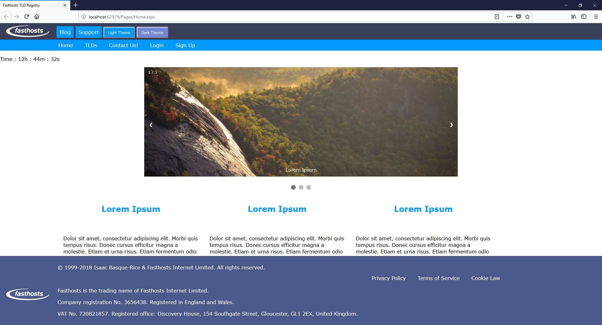

Screenshot 32

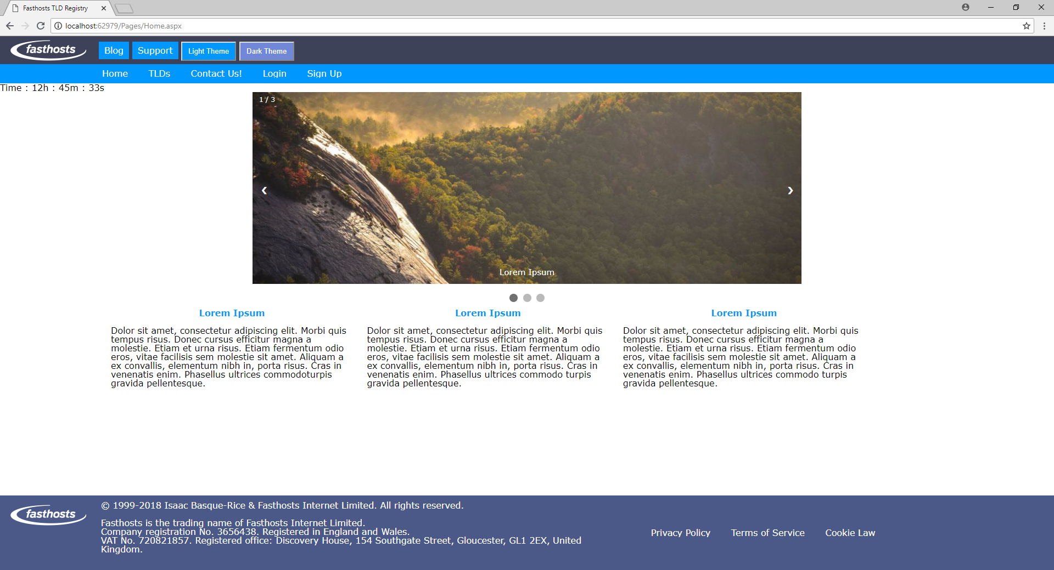

Screenshot 33

The top screenshot is in Firefox, the bottom in chrome, as one can clearly see, the footer is significantly larger in Firefox than in chrome, this is due to the fact I haven’t yet implemented the reset.css file and as such each browser applies its own base CSS styling. In addition, as indicated by the red boxes, heading and padding for <h(n)> elements is significantly different between the browsers, this serves as further proof of a need for a reset.css file.

# References

Chisholm, W., Vanderheiden, G. & Jacobs, I., 1999. *Checklist of Checkpoints for Web Content Accessibility Guidelines 1.0.* [Online]   
Available at: https://www.w3.org/TR/WAI-WEBCONTENT/full-checklist.html  
[Accessed 23 June 2018].

Larsen, A., 2017. *WHY IS DATA IMPORTANT FOR YOUR BUSINESS?.* [Online]   
Available at: https://blog.grow.com/data-important-business/

Lawton-Henry, S. et al., n.d. *Web Design and Applications - Accessability.* [Online]   
Available at: https://www.w3.org/standards/webdesign/accessibility

MIT (1), 1998. *Project98 - Log.html.* [Online]   
Available at: http://web.mit.edu/ecom/www/Project98/G2/log.html  
[Accessed 4 July 2018].

MIT, 1998. *Data Collection: Defining the Customer.* [Online]   
Available at: http://web.mit.edu/ecom/www/Project98/G2/data.htm  
[Accessed 4 July 2018].

W3Schools, n.d. *HTML5 New Elements.* [Online]   
Available at: https://www.w3schools.com/html/html5_new_elements.asp

WebWise , 2012. *What are cookies?.* [Online]   
Available at: http://www.bbc.co.uk/webwise/guides/about-cookies  
[Accessed 3 July 2018].